МІНІСТЕРСТВО ОСВІТИ І НАУКИ УКРАЇНИ НАЦІОНАЛЬНИЙ ТЕХНІЧНИЙ УНІВЕРСИТЕТ «ХАРКІВСЬКИЙ ПОЛІТЕХНІЧНИЙ ІНСТИТУТ» Кафедра «Програмна інженерія та інформаційні технології управління»

Розграхункове графічне завдання

З предмету «Дискретна математика»

Варіант № 22

Виконав

Студент групи КН-36а

Рубан Ю.Д.

Перевірив:

Проф. каф ПІіТУ

Гужва В. О.

Харків 2017

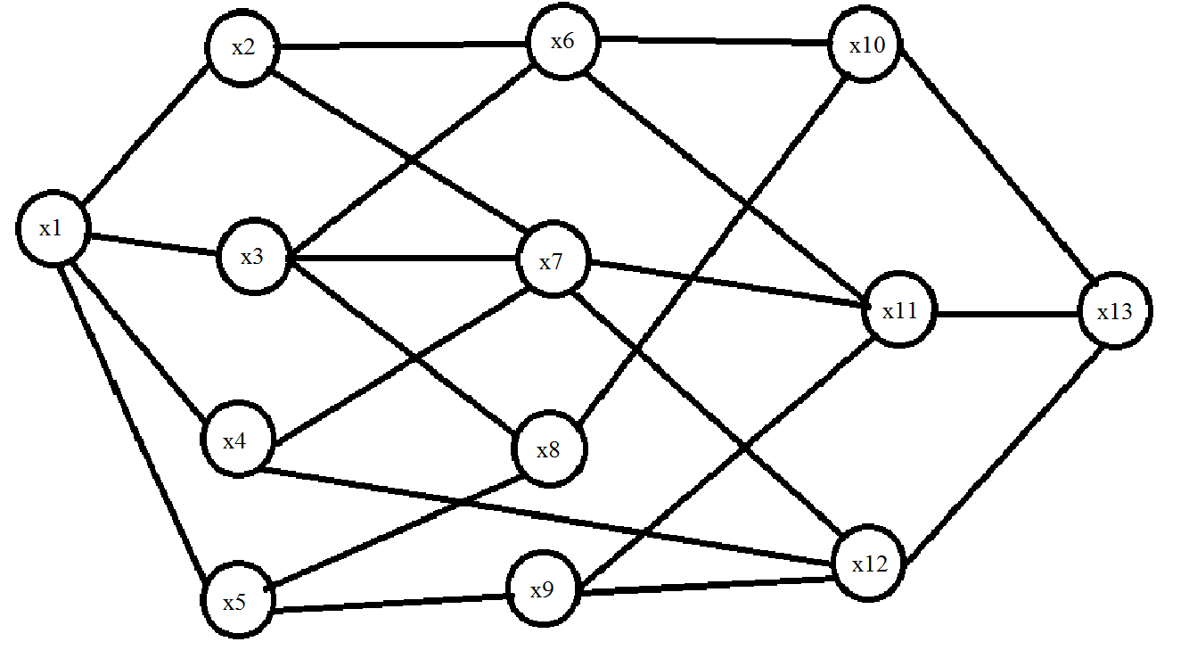

**Матрица смежности для неориентированого графа**

|  |  |  |  |  |  |  |  |  |  |  |  |  |  |
| --- | --- | --- | --- | --- | --- | --- | --- | --- | --- | --- | --- | --- | --- |
|  | X1 | X2 | X3 | X4 | X5 | X6 | X7 | X8 | X9 | X10 | X11 | X12 | X13 |
| X1 | 0 | 1 | 1 | 1 | 1 | 0 | 0 | 0 | 0 | 0 | 0 | 0 | 0 |
| X2 | 1 | 0 | 0 | 0 | 0 | 1 | 1 | 0 | 0 | 0 | 0 | 0 | 0 |
| X3 | 1 | 0 | 0 | 0 | 0 | 1 | 1 | 1 | 0 | 0 | 0 | 0 | 0 |
| X4 | 1 | 0 | 0 | 0 | 0 | 0 | 1 | 0 | 0 | 0 | 0 | 1 | 0 |
| X5 | 1 | 0 | 0 | 0 | 0 | 0 | 0 | 1 | 1 | 0 | 0 | 0 | 0 |
| X6 | 0 | 1 | 1 | 0 | 0 | 0 | 0 | 0 | 0 | 1 | 1 | 0 | 0 |
| X7 | 0 | 1 | 1 | 1 | 0 | 0 | 0 | 0 | 0 | 0 | 1 | 1 | 0 |
| X8 | 0 | 0 | 1 | 0 | 1 | 0 | 0 | 0 | 0 | 1 | 0 | 0 | 0 |
| X9 | 0 | 0 | 0 | 0 | 1 | 0 | 0 | 0 | 0 | 0 | 1 | 1 | 0 |
| X10 | 0 | 0 | 0 | 0 | 0 | 1 | 0 | 1 | 0 | 0 | 0 | 0 | 1 |
| X11 | 0 | 0 | 1 | 0 | 0 | 1 | 0 | 0 | 1 | 0 | 0 | 0 | 1 |
| X12 | 0 | 0 | 0 | 1 | 0 | 0 | 1 | 0 | 1 | 0 | 0 | 0 | 1 |
| X13 | 0 | 0 | 0 | 0 | 0 | 0 | 0 | 0 | 0 | 1 | 1 | 1 | 0 |

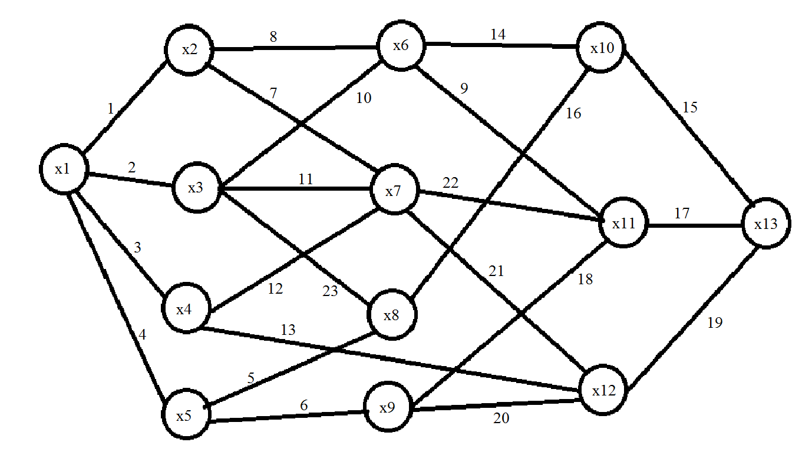

**Матрица инциденций для неориентированого графа**

|  |  |  |  |  |  |  |  |  |  |  |  |  |  |  |  |  |  |  |  |  |  |  |  |
| --- | --- | --- | --- | --- | --- | --- | --- | --- | --- | --- | --- | --- | --- | --- | --- | --- | --- | --- | --- | --- | --- | --- | --- |
|  | 1 | 2 | 3 | 4 | 5 | 6 | 7 | 8 | 9 | 10 | 11 | 12 | 13 | 14 | 15 | 16 | 17 | 18 | 19 | 20 | 21 | 22 | 23 |
| X1 | 1 | 1 | 1 | 1 | 0 | 0 | 0 | 0 | 0 | 0 | 0 | 0 | 0 | 0 | 0 | 0 | 0 | 0 | 0 | 0 | 0 | 0 | 0 |
| X2 | 1 | 0 | 0 | 0 | 0 | 0 | 1 | 1 | 0 | 0 | 0 | 0 | 0 | 0 | 0 | 0 | 0 | 0 | 0 | 0 | 0 | 0 | 0 |
| X3 | 0 | 1 | 0 | 0 | 0 | 0 | 0 | 0 | 0 | 1 | 1 | 0 | 0 | 0 | 0 | 0 | 0 | 0 | 0 | 0 | 0 | 0 | 1 |
| X4 | 0 | 0 | 1 | 0 | 0 | 0 | 0 | 0 | 0 | 0 | 0 | 1 | 1 | 0 | 0 | 0 | 0 | 0 | 0 | 0 | 0 | 0 | 0 |
| X5 | 0 | 0 | 0 | 1 | 1 | 1 | 0 | 0 | 0 | 0 | 0 | 0 | 0 | 0 | 0 | 0 | 0 | 0 | 0 | 0 | 0 | 0 | 0 |
| X6 | 0 | 0 | 0 | 0 | 0 | 0 | 0 | 1 | 1 | 1 | 0 | 0 | 0 | 1 | 0 | 0 | 0 | 0 | 0 | 0 | 0 | 0 | 0 |
| X7 | 0 | 0 | 0 | 0 | 0 | 0 | 1 | 0 | 0 | 0 | 1 | 1 | 0 | 0 | 0 | 0 | 0 | 0 | 0 | 0 | 1 | 1 | 0 |
| X8 | 0 | 0 | 0 | 0 | 1 | 0 | 0 | 0 | 0 | 0 | 0 | 0 | 0 | 0 | 0 | 1 | 0 | 0 | 0 | 0 | 0 | 0 | 1 |
| X9 | 0 | 0 | 0 | 0 | 0 | 1 | 0 | 0 | 0 | 0 | 0 | 0 | 0 | 0 | 0 | 0 | 0 | 1 | 0 | 1 | 0 | 0 | 0 |
| X10 | 0 | 0 | 0 | 0 | 0 | 0 | 0 | 0 | 0 | 0 | 0 | 0 | 0 | 1 | 1 | 1 | 0 | 0 | 0 | 0 | 0 | 0 | 0 |
| X11 | 0 | 0 | 0 | 0 | 0 | 0 | 0 | 0 | 1 | 0 | 0 | 0 | 0 | 0 | 0 | 0 | 1 | 1 | 0 | 0 | 0 | 1 | 0 |
| X12 | 0 | 0 | 0 | 0 | 0 | 0 | 0 | 0 | 0 | 0 | 0 | 0 | 1 | 0 | 0 | 0 | 0 | 0 | 1 | 1 | 1 | 0 | 0 |
| X13 | 0 | 0 | 0 | 0 | 0 | 0 | 0 | 0 | 0 | 0 | 0 | 0 | 0 | 0 | 1 | 0 | 1 | 0 | 1 | 0 | 0 | 0 | 0 |

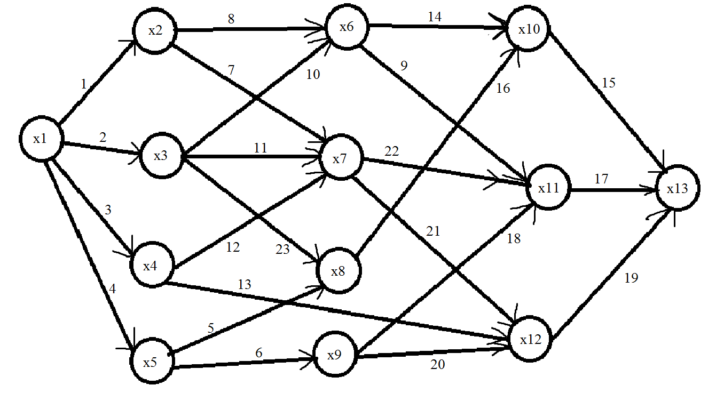

**Матрица смежности для ориентированого графа**

|  |  |  |  |  |  |  |  |  |  |  |  |  |  |
| --- | --- | --- | --- | --- | --- | --- | --- | --- | --- | --- | --- | --- | --- |
|  | X1 | X2 | X3 | X4 | X5 | X6 | X7 | X8 | X9 | X10 | X11 | X12 | X13 |
| X1 | 0 | 1 | 1 | 1 | 1 | 0 | 0 | 0 | 0 | 0 | 0 | 0 | 0 |
| X2 | 0 | 0 | 0 | 0 | 0 | 1 | 1 | 0 | 0 | 0 | 0 | 0 | 0 |
| X3 | 0 | 0 | 0 | 0 | 0 | 1 | 1 | 1 | 0 | 0 | 0 | 0 | 0 |
| X4 | 0 | 0 | 0 | 0 | 0 | 0 | 1 | 0 | 0 | 0 | 0 | 1 | 0 |
| X5 | 0 | 0 | 0 | 0 | 0 | 0 | 0 | 1 | 1 | 0 | 0 | 0 | 0 |
| X6 | 0 | 0 | 0 | 0 | 0 | 0 | 0 | 0 | 0 | 1 | 1 | 0 | 0 |
| X7 | 0 | 0 | 0 | 0 | 0 | 0 | 0 | 0 | 0 | 0 | 1 | 1 | 0 |
| X8 | 0 | 0 | 0 | 0 | 0 | 0 | 0 | 0 | 0 | 1 | 0 | 0 | 0 |
| X9 | 0 | 0 | 0 | 0 | 0 | 0 | 0 | 0 | 0 | 0 | 1 | 1 | 0 |
| X10 | 0 | 0 | 0 | 0 | 0 | 0 | 0 | 0 | 0 | 0 | 0 | 0 | 1 |
| X11 | 0 | 0 | 0 | 0 | 0 | 0 | 0 | 0 | 0 | 0 | 0 | 0 | 1 |
| X12 | 0 | 0 | 0 | 0 | 0 | 0 | 0 | 0 | 0 | 0 | 0 | 0 | 1 |
| X13 | 0 | 0 | 0 | 0 | 0 | 0 | 0 | 0 | 0 | 0 | 0 | 0 | 0 |

**Матрица инциденций для ориентрированого графа**

|  |  |  |  |  |  |  |  |  |  |  |  |  |  |  |  |  |  |  |  |  |  |  |  |
| --- | --- | --- | --- | --- | --- | --- | --- | --- | --- | --- | --- | --- | --- | --- | --- | --- | --- | --- | --- | --- | --- | --- | --- |
|  | 1 | 2 | 3 | 4 | 5 | 6 | 7 | 8 | 9 | 10 | 11 | 12 | 13 | 14 | 15 | 16 | 17 | 18 | 19 | 20 | 21 | 22 | 23 |
| X1 | 1 | 1 | 1 | 1 | 0 | 0 | 0 | 0 | 0 | 0 | 0 | 0 | 0 | 0 | 0 | 0 | 0 | 0 | 0 | 0 | 0 | 0 | 0 |
| X2 | -1 | 0 | 0 | 0 | 0 | 0 | 1 | 1 | 0 | 0 | 0 | 0 | 0 | 0 | 0 | 0 | 0 | 0 | 0 | 0 | 0 | 0 | 0 |
| X3 | 0 | -1 | 0 | 0 | 0 | 0 | 0 | 0 | 0 | 1 | 1 | 0 | 0 | 0 | 0 | 0 | 0 | 0 | 0 | 0 | 0 | 0 | 1 |
| X4 | 0 | 0 | -1 | 0 | 0 | 0 | 0 | 0 | 0 | 0 | 0 | 1 | 1 | 0 | 0 | 0 | 0 | 0 | 0 | 0 | 0 | 0 | 0 |
| X5 | 0 | 0 | 0 | -1 | 1 | 1 | 0 | 0 | 0 | 0 | 0 | 0 | 0 | 0 | 0 | 0 | 0 | 0 | 0 | 0 | 0 | 0 | 0 |
| X6 | 0 | 0 | 0 | 0 | 0 | 0 | 0 | -1 | 1 | -1 | 0 | 0 | 0 | 1 | 0 | 0 | 0 | 0 | 0 | 0 | 0 | 0 | 0 |
| X7 | 0 | 0 | 0 | 0 | 0 | 0 | -1 | 0 | 0 | 0 | -1 | -1 | 0 | 0 | 0 | 0 | 0 | 0 | 0 | 0 | 1 | 1 | 0 |
| X8 | 0 | 0 | 0 | 0 | -1 | 0 | 0 | 0 | 0 | 0 | 0 | 0 | 0 | 0 | 0 | 1 | 0 | 0 | 0 | 0 | 0 | 0 | -1 |
| X9 | 0 | 0 | 0 | 0 | 0 | -1 | 0 | 0 | 0 | 0 | 0 | 0 | 0 | 0 | 0 | 0 | 0 | 1 | 0 | 1 | 0 | 0 | 0 |
| X10 | 0 | 0 | 0 | 0 | 0 | 0 | 0 | 0 | 0 | 0 | 0 | 0 | 0 | -1 | 1 | -1 | 0 | 0 | 0 | 0 | 0 | 0 | 0 |
| X11 | 0 | 0 | 0 | 0 | 0 | 0 | 0 | 0 | -1 | 0 | 0 | 0 | 0 | 0 | 0 | 0 | 1 | -1 | 0 | 0 | 0 | -1 | 0 |
| X12 | 0 | 0 | 0 | 0 | 0 | 0 | 0 | 0 | 0 | 0 | 0 | 0 | -1 | 0 | 0 | 0 | 0 | 0 | 1 | -1 | -1 | 0 | 0 |
| X13 | 0 | 0 | 0 | 0 | 0 | 0 | 0 | 0 | 0 | 0 | 0 | 0 | 0 | 0 | -1 | 0 | -1 | 0 | -1 | 0 | 0 | 0 | 0 |

Матрица смежности в третьей степени

|  |  |  |  |  |  |  |  |  |  |  |  |  |  |
| --- | --- | --- | --- | --- | --- | --- | --- | --- | --- | --- | --- | --- | --- |
|  | X1 | X2 | X3 | X4 | X5 | X6 | X7 | X8 | X9 | X10 | X11 | X12 | X13 |
| X1 | 0 | 0 | 0 | 0 | 0 | 0 | 0 | 0 | 0 | 4 | 6 | 4 | 1 |
| X2 | 0 | 0 | 0 | 0 | 0 | 0 | 0 | 0 | 0 | 0 | 0 | 0 | 4 |
| X3 | 0 | 0 | 0 | 0 | 0 | 0 | 0 | 0 | 0 | 0 | 0 | 0 | 5 |
| X4 | 0 | 0 | 0 | 0 | 0 | 0 | 0 | 0 | 0 | 0 | 0 | 0 | 2 |
| X5 | 0 | 0 | 0 | 0 | 0 | 0 | 0 | 0 | 0 | 0 | 0 | 0 | 3 |
| X6 | 0 | 0 | 0 | 0 | 0 | 0 | 0 | 0 | 0 | 0 | 0 | 0 | 0 |
| X7 | 0 | 0 | 0 | 0 | 0 | 0 | 0 | 0 | 0 | 0 | 0 | 0 | 0 |
| X8 | 0 | 0 | 0 | 0 | 0 | 0 | 0 | 0 | 0 | 0 | 0 | 0 | 0 |
| X9 | 0 | 0 | 0 | 0 | 0 | 0 | 0 | 0 | 0 | 0 | 0 | 0 | 0 |
| X10 | 0 | 0 | 0 | 0 | 0 | 0 | 0 | 0 | 0 | 0 | 0 | 0 | 0 |
| X11 | 0 | 0 | 0 | 0 | 0 | 0 | 0 | 0 | 0 | 0 | 0 | 0 | 0 |
| X12 | 0 | 0 | 0 | 0 | 0 | 0 | 0 | 0 | 0 | 0 | 0 | 0 | 0 |
| X13 | 0 | 0 | 0 | 0 | 0 | 0 | 0 | 0 | 0 | 0 | 0 | 0 | 0 |

R(x1) = {x1} U {x2 x3 x4 x5} U {x6 x7 x8 x12 x9} U {x10 x11 x12 x13} U {x13} U {} = {x1 x2 x3 x4 x5 x6 x7 x8 x9 x10 x11 x12 x13}

R(x2) = {x2} U {x6 x7} U {x10 x11 x12} U {x13} U {} = {x2 x6 x7 x10 x11 x12 x13}

R(x3) = {x3} U {x6 x7 x8} U {x10 x11 x12} U {x13} U {} = {x3 x6 x7 x8 x10 x11 x12 x13}

R(x4) = {x4} U {x7 x12} U {x11 x12 x13} U {} = {x4 x7 x11 x12 x13}

R(x5) = {x5} U {x8 x9} U {x10 x11 x12} U {x13} U {} = {x5 x8 x9 x10 x11 x12 x13}

R(x6) = {x6} U {x10 x11} U {x13} U {} = {x6 x10 x11 x13}

R(x7) = {x7} U {x11 x12} U {x13} U {} = {x7 x11 x12 x13}

R(x8) = {x8} U {x10} U {x13} U {} = {x8 x10 x13}

R(x9) = {x9} U {x11 x12} U {x13} U {} = {x9 x11 x12 x13}

R(x10) = {x10} U {x13} U {} = {x10 x13}

R(x11) = {x11} U {x13} U {} = {x11 x13}

R(x12) = {x12} U {x13} U {} = {x12 x13}

R(x13) = {x13} U {} = {x13}

**Матрица достижимости для ориентированого графа R**

|  |  |  |  |  |  |  |  |  |  |  |  |  |  |
| --- | --- | --- | --- | --- | --- | --- | --- | --- | --- | --- | --- | --- | --- |
|  | X1 | X2 | X3 | X4 | X5 | X6 | X7 | X8 | X9 | X10 | X11 | X12 | X13 |
| X1 | 1 | 1 | 1 | 1 | 1 | 1 | 1 | 1 | 1 | 1 | 1 | 1 | 1 |
| X2 |  | 1 |  |  |  | 1 | 1 |  |  | 1 | 1 | 1 | 1 |
| X3 |  |  | 1 |  |  | 1 | 1 |  |  | 1 | 1 | 1 | 1 |
| X4 |  |  |  | 1 |  |  | 1 |  |  |  | 1 | 1 | 1 |
| X5 |  |  |  |  | 1 |  |  | 1 | 1 | 1 | 1 | 1 | 1 |
| X6 |  |  |  |  |  | 1 |  |  |  | 1 | 1 | 1 | 1 |
| X7 |  |  |  |  |  |  | 1 |  |  |  | 1 | 1 | 1 |
| X8 |  |  |  |  |  |  |  | 1 |  | 1 |  |  | 1 |
| X9 |  |  |  |  |  |  |  |  | 1 |  | 1 | 1 | 1 |
| X10 |  |  |  |  |  |  |  |  |  | 1 |  |  | 1 |
| X11 |  |  |  |  |  |  |  |  |  |  | 1 |  | 1 |
| X12 |  |  |  |  |  |  |  |  |  |  |  | 1 | 1 |
| X13 |  |  |  |  |  |  |  |  |  |  |  |  | 1 |

**Матрица контр-достижимости для ориентированого графа Q**

|  |  |  |  |  |  |  |  |  |  |  |  |  |  |
| --- | --- | --- | --- | --- | --- | --- | --- | --- | --- | --- | --- | --- | --- |
|  | X1 | X2 | X3 | X4 | X5 | X6 | X7 | X8 | X9 | X10 | X11 | X12 | X13 |
| X1 | 1 |  |  |  |  |  |  |  |  |  |  |  |  |
| X2 | 1 | 1 |  |  |  |  |  |  |  |  |  |  |  |
| X3 | 1 |  | 1 |  |  |  |  |  |  |  |  |  |  |
| X4 | 1 |  |  | 1 |  |  |  |  |  |  |  |  |  |
| X5 | 1 |  |  |  | 1 |  |  |  |  |  |  |  |  |
| X6 | 1 | 1 | 1 |  |  | 1 |  |  |  |  |  |  |  |
| X7 | 1 | 1 | 1 | 1 |  |  | 1 |  |  |  |  |  |  |
| X8 | 1 |  | 1 |  | 1 |  |  | 1 |  |  |  |  |  |
| X9 | 1 |  |  |  | 1 |  |  |  | 1 |  |  |  |  |
| X10 | 1 | 1 | 1 |  | 1 | 1 |  | 1 |  | 1 |  |  |  |
| X11 | 1 | 1 | 1 | 1 | 1 | 1 | 1 |  | 1 |  | 1 |  |  |
| X12 | 1 | 1 | 1 | 1 | 1 | 1 | 1 |  | 1 |  |  | 1 |  |
| X13 | 1 | 1 | 1 | 1 | 1 | 1 | 1 | 1 | 1 | 1 | 1 | 1 | 1 |

**Матрица RQ**

|  |  |  |  |  |  |  |  |  |  |  |  |  |  |
| --- | --- | --- | --- | --- | --- | --- | --- | --- | --- | --- | --- | --- | --- |
|  | X1 | X2 | X3 | X4 | X5 | X6 | X7 | X8 | X9 | X10 | X11 | X12 | X13 |
| X1 | 1 |  |  |  |  |  |  |  |  |  |  |  |  |
| X2 |  | 1 |  |  |  |  |  |  |  |  |  |  |  |
| X3 |  |  | 1 |  |  |  |  |  |  |  |  |  |  |
| X4 |  |  |  | 1 |  |  |  |  |  |  |  |  |  |
| X5 |  |  |  |  | 1 |  |  |  |  |  |  |  |  |
| X6 |  |  |  |  |  | 1 |  |  |  |  |  |  |  |
| X7 |  |  |  |  |  |  | 1 |  |  |  |  |  |  |
| X8 |  |  |  |  |  |  |  | 1 |  |  |  |  |  |
| X9 |  |  |  |  |  |  |  |  | 1 |  |  |  |  |
| X10 |  |  |  |  |  |  |  |  |  | 1 |  |  |  |
| X11 |  |  |  |  |  |  |  |  |  |  | 1 |  |  |
| X12 |  |  |  |  |  |  |  |  |  |  |  | 1 |  |
| X13 |  |  |  |  |  |  |  |  |  |  |  |  | 1 |

X1* = {x1}

X2* = {x2}

X3* = {x3}

X4* = {x4}

X5* = {x5}

X6* = {x6}

X7* = {x7}

X8* = {x8}

X9* = {x9}

X10* = {x10}

X11* = {x11}

X12* = {x12}

X13* = {x13}

Матрица конденсаций совпадает с исходным графом

**Матрица расстояний**

|  |  |  |  |  |  |  |  |  |  |  |  |  |  |
| --- | --- | --- | --- | --- | --- | --- | --- | --- | --- | --- | --- | --- | --- |
|  | X1 | X2 | X3 | X4 | X5 | X6 | X7 | X8 | X9 | X10 | X11 | X12 | X13 |
| X1 | 0 | 4 | 3 | 3 | 5 | ∞ | ∞ | ∞ | ∞ | ∞ | ∞ | ∞ | ∞ |
| X2 | ∞ | 0 | ∞ | ∞ | ∞ | 2 | 2 | ∞ | ∞ | ∞ | ∞ | ∞ | ∞ |
| X3 | ∞ | ∞ | 0 | ∞ | ∞ | 1 | 1 | 2 | ∞ | ∞ | ∞ | ∞ | ∞ |
| X4 | ∞ | ∞ | ∞ | 0 | ∞ | ∞ | 1 | ∞ | ∞ | ∞ | ∞ | 2 | ∞ |
| X5 | ∞ | ∞ | ∞ | ∞ | 0 | ∞ | ∞ | 2 | 3 | ∞ | ∞ | ∞ | ∞ |
| X6 | ∞ | ∞ | ∞ | ∞ | ∞ | 0 | ∞ | ∞ | ∞ | 1 | 2 | ∞ | ∞ |
| X7 | ∞ | ∞ | ∞ | ∞ | ∞ | ∞ | 0 | ∞ | ∞ | ∞ | 1 | 3 | ∞ |
| X8 | ∞ | ∞ | ∞ | ∞ | ∞ | ∞ | ∞ | 0 | ∞ | 3 | ∞ | ∞ | ∞ |
| X9 | ∞ | ∞ | ∞ | ∞ | ∞ | ∞ | ∞ | ∞ | 0 | ∞ | 3 | 3 | ∞ |
| X10 | ∞ | ∞ | ∞ | ∞ | ∞ | ∞ | ∞ | ∞ | ∞ | 0 | ∞ | ∞ | 5 |
| X11 | ∞ | ∞ | ∞ | ∞ | ∞ | ∞ | ∞ | ∞ | ∞ | ∞ | 0 | ∞ | 6 |
| X12 | ∞ | ∞ | ∞ | ∞ | ∞ | ∞ | ∞ | ∞ | ∞ | ∞ | ∞ | 0 | 5 |
| X13 | ∞ | ∞ | ∞ | ∞ | ∞ | ∞ | ∞ | ∞ | ∞ | ∞ | ∞ | ∞ | 0 |

**Алгоритм Дейкстры**

y = x1;

d(x2) = min{d(x2),d(y) + a(y; x2)} = min{} = 4;

d(x3) = min{d(x3), d(y)+a(y; x3)} = min{; 0 + 3} = 3;

d(x4) = min{d(x4), d(y)+a(y; x4)} = min{; 0 + 3} = 3;

d(x5) = min{d(x5), d(y)+a(y;x5)} = min{; 0 + 5} = 5;

y = x3;

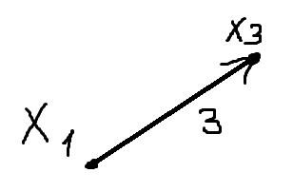

d(x6) = min{d(x6), d(y)+a(y; x6)} = min{; 3 + 1} = 4;

d(x7) = min{d(x7), d(y)+a(y; x7)} = min{; 3 + 1} = 4;

d(x8) = min{d(x8), d(y)+a(y; x8)} = min{; 3 + 2} = 5;

d(x2) = 4;

d(x4) = 3;

d(x5) = 5;

y = x4;

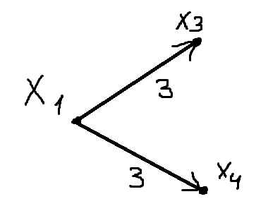

d(x7) = min{d(x7), d(y)+a(y; x7)} = min{4; 3 + 1} = 4;

d(x12) = min{d(x12), d(y)+a(y; x12)} = min{; 3 + 2 } = 5;

d(x2) = 4;

d(x5) = 5;

d(x8) = 5;

y = x2;

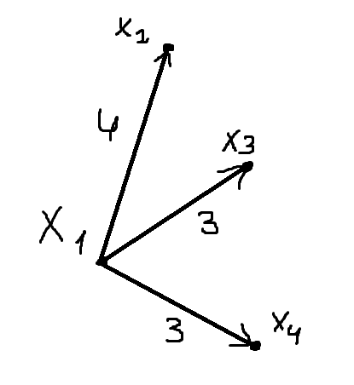

d(x6) = min{d(x6), d(y)+a(y; x6)} = min{4; 4 + 2} = 4;

d(x7) = min{d(x7), d(y)+a(y; x7)} = min{4; 4 + 2} = 4;

d(x12) = 5;

d(x5) = 5;

d(x8) = 5;

y = x6;

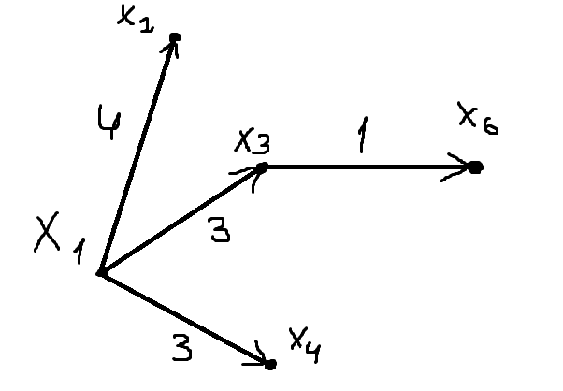

d(x10) = min{d(x10), d(y)+a(y; x10)} = min{; 4 + 1} = 5;

d(x11) = min{d(x11), d(y)+a(y; x11)} = min{;4 + 2} = 6;

d(x12) = 5;

d(x5) = 5;

d(x8) = 5;

d(x7) = 4;

y = x7;

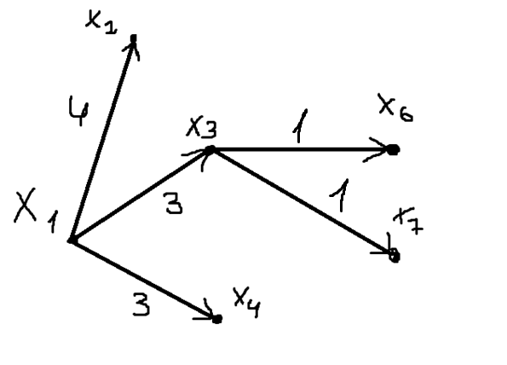d(x11) = min{d(x11), d(y)+a(y; x11)} = min{6;4 + 1} = 5;

d(x12) = min{d(x12), d(y)+a(y; x12)} = min{5;4 + 3} = 5;

d(x5) = 5;

d(x8) = 5;

d(x10) = 5;

y = x5;

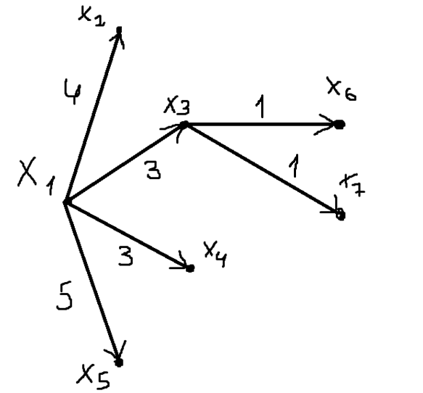

d(x8) = min{d(x8), d(y)+a(y; x8)} = min{5;5 + 2} = 5;

d(x9) = min{d(x9), d(y)+a(y; x9)} = min{∞;5 + 3} = 8;

d(x10) = 5;

d(x11) = 5;

d(x12) = 5;

y = x8

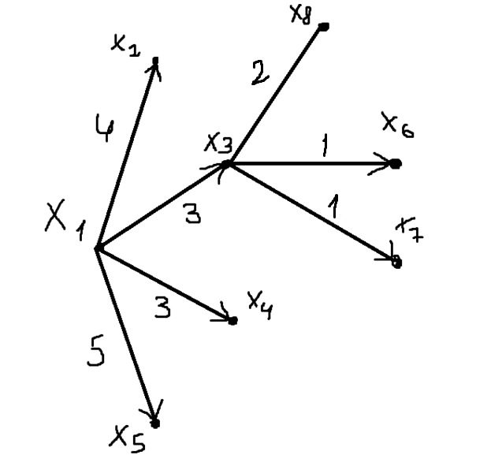d(x10) = min{d(x10), d(y)+a(y; x10)} = min{5;5 + 3} = 5;

d(x9) = 8;

d(x11) = 5;

d(x12) = 5;

y = x10

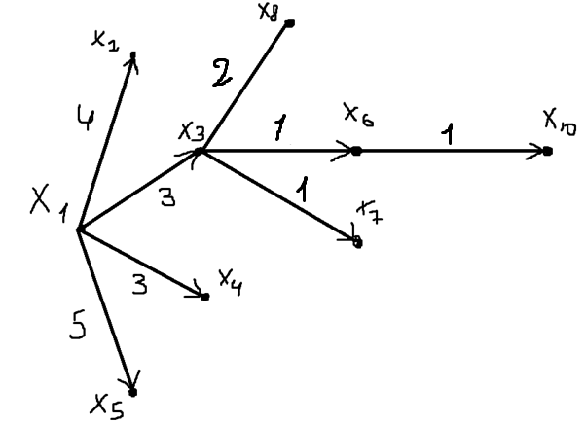d(x13) = min{d(x13), d(y)+a(y; x13)} = min{∞;5 + 5} = 10;

d(x9) = 8;

d(x11) = 5;

d(x12) = 5;

y = x11

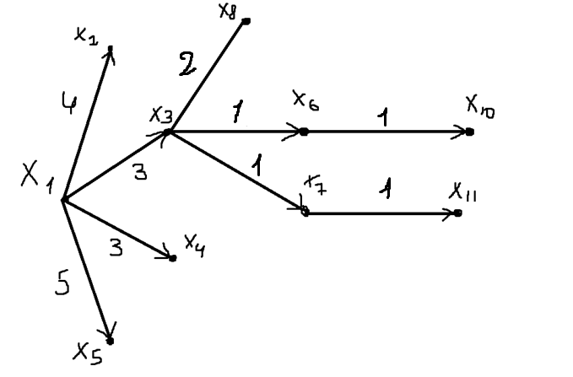d(x13) = min{d(x13), d(y)+a(y; x13)} = min{10;5 + 6} = 10;

d(x9) = 8;

d(x12) = 5;

y = x12

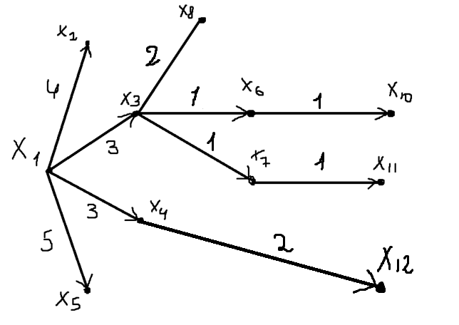d(x13) = min{d(x13), d(y)+a(y; x13)} = min{10;5 + 5} = 10;

d(x9) = 8;

y = x9

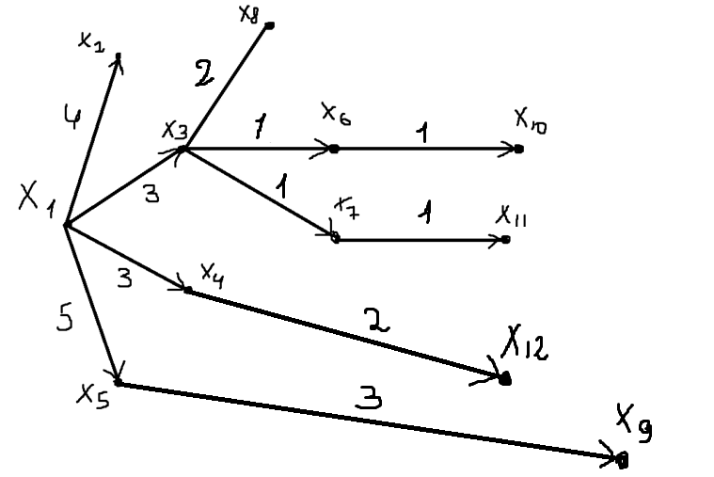

d(x13) = 10

y = x13

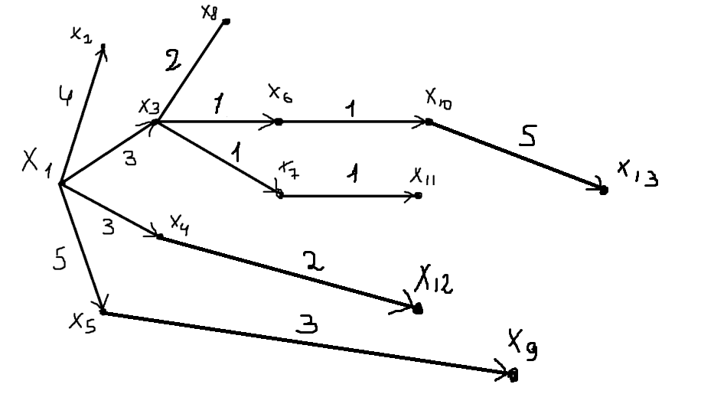

Минимальное расстояние от x1 до x13 равно 10 и является не единственным так, как выбрано не однозначностью выбора

Минимальный путь (x1, x3)(x3, x6)(x6, x10)(x10, x13)

**Алгоритм Данцига**

D0 =

|  |  |  |  |  |  |  |  |  |  |  |  |  |  |
| --- | --- | --- | --- | --- | --- | --- | --- | --- | --- | --- | --- | --- | --- |
|  | X1 | X2 | X3 | X4 | X5 | X6 | X7 | X8 | X9 | X10 | X11 | X12 | X13 |
| X1 | 0 | 4 | 3 | 3 | 5 | ∞ | ∞ | ∞ | ∞ | ∞ | ∞ | ∞ | ∞ |
| X2 | ∞ | 0 | ∞ | ∞ | ∞ | 2 | 2 | ∞ | ∞ | ∞ | ∞ | ∞ | ∞ |
| X3 | ∞ | ∞ | 0 | ∞ | ∞ | 1 | 1 | 2 | ∞ | ∞ | ∞ | ∞ | ∞ |
| X4 | ∞ | ∞ | ∞ | 0 | ∞ | ∞ | 1 | ∞ | ∞ | ∞ | ∞ | 2 | ∞ |
| X5 | ∞ | ∞ | ∞ | ∞ | 0 | ∞ | ∞ | 2 | 3 | ∞ | ∞ | ∞ | ∞ |
| X6 | ∞ | ∞ | ∞ | ∞ | ∞ | 0 | ∞ | ∞ | ∞ | 1 | 2 | ∞ | ∞ |
| X7 | ∞ | ∞ | ∞ | ∞ | ∞ | ∞ | 0 | ∞ | ∞ | ∞ | 1 | 3 | ∞ |
| X8 | ∞ | ∞ | ∞ | ∞ | ∞ | ∞ | ∞ | 0 | ∞ | 3 | ∞ | ∞ | ∞ |
| X9 | ∞ | ∞ | ∞ | ∞ | ∞ | ∞ | ∞ | ∞ | 0 | ∞ | 3 | 3 | ∞ |
| X10 | ∞ | ∞ | ∞ | ∞ | ∞ | ∞ | ∞ | ∞ | ∞ | 0 | ∞ | ∞ | 5 |
| X11 | ∞ | ∞ | ∞ | ∞ | ∞ | ∞ | ∞ | ∞ | ∞ | ∞ | 0 | ∞ | 6 |
| X12 | ∞ | ∞ | ∞ | ∞ | ∞ | ∞ | ∞ | ∞ | ∞ | ∞ | ∞ | 0 | 5 |
| X13 | ∞ | ∞ | ∞ | ∞ | ∞ | ∞ | ∞ | ∞ | ∞ | ∞ | ∞ | ∞ | 0 |

D1 = (d111) = (0)

d212= min{d111+ d012} = min{0 + 4} = 4

d121 = min{ d111 + d021} = min{0 + ∞} = ∞;

|  |  |
| --- | --- |
| 0 | 4 |
| ∞ | 0 |

|  |  |
| --- | --- |
| - | (x1, x2) |
| - | - |

D2 = Пути –

|  |  |  |
| --- | --- | --- |
| 0 | d312 | d313 |
| d321 | 0 | d323 |
| d331 | d332 | 0 |

D3 =

d313 = min{d211+ d013, d212+ d023} = min{0 + 3; ∞ + ∞} = 3

d323 = min{d221+ d013, d222+ d023} = min{∞ + 3;∞ + ∞} = ∞

d331 = min{d031 + d211, d031 + d221 } = min{∞ + 0;∞ + ∞ } = ∞

d332 = min{ d031 + d212, d032 + d222} = min{∞ + 4; ∞ + 0} = ∞

d312 = min{ d313 + d332, d012} = min{3 + ∞; 4} = 4

d321 = min{ d323 + d331, d021} = min{∞ + ∞; ∞} = ∞

|  |  |  |
| --- | --- | --- |
| - | (x1,x2) | (x1,x3) |
| - | - | - |
| - | - | - |

|  |  |  |
| --- | --- | --- |
| 0 | 4 | 3 |
| ∞ | 0 | ∞ |
| ∞ | ∞ | 0 |

D3 = Пути -

|  |  |  |  |
| --- | --- | --- | --- |
| 0 | d412 | d413 | d414 |
| d421 | 0 | d423 | d424 |
| d431 | d432 | 0 | d434 |
| d441 | d442 | d443 | 0 |

D4 =

d414 = min{ d311+ d014, d321+ d024, d313 + d034} = min{0 + 3; ∞ + ∞; 3 + ∞} = 3

d424 = min{ d321+ d014, d322+ d024, d323+ d034} = min{∞ + 3; 0 + ∞; ∞ + ∞} = ∞

d434 = min{ d331+ d014, d323+ d024, d333+ d034} = min{∞ + 3; ∞ + ∞; 0 + ∞} = ∞

d421=d431=d441=d432=d442=d443 = ∞.

Так как граф задан таким образом, что не существует путейиз большей вершины к меньшей

d412 = min{ d414 + d442 , d312} = min{∞ + ∞; 4} = 4

d413 = min{ d414 + d443 , d313} = min{∞ + ∞; 3} = 3

d423 = min{ d424 + d443 , d323} = min{∞ + ∞; ∞} = ∞

|  |  |  |  |
| --- | --- | --- | --- |
| 0 | 4 | 3 | 3 |
| ∞ | 0 | ∞ | ∞ |
| ∞ | ∞ | 0 | ∞ |
| ∞ | ∞ | ∞ | 0 |

|  |  |  |  |
| --- | --- | --- | --- |
| - | (x1;x2) | (x1;x3) | (x1;x3) |
| - | - | - | - |
| - | - | - | - |
| - | - | - | - |

D4 = Пути -

|  |  |  |  |  |
| --- | --- | --- | --- | --- |
| 0 | d512 | d513 | d514 | d515 |
| d521 | 0 | d523 | d524 | d525 |
| d531 | d532 | 0 | d534 | d535 |
| d541 | d542 | d543 | 0 | d545 |
| d551 | d552 | d553 | d554 | 0 |

D5 =

d521 = d531 = d541 = d551 = d532 = d542 = d552 = d543 = d553 = d554 = ∞

d515 = min{ d411 + d015; d412 + d025; d413 + d035; d414 + d045} = min{0+5;4+∞;3+∞;3+∞} = 5

d525 = min{ d421 + d015; d422 + d025; d423 + d035; d424 + d045} = min{∞+5;0+∞;∞+∞;∞+∞} = ∞

d535 = min{ d431 + d015; d432 + d025; d433 + d035; d434 + d045} = min{∞+5;∞+∞;0+∞;∞+∞} = ∞

d545 = min{ d441 + d015; d442 + d025; d443 + d035; d444 + d045} = min{∞+5;∞+∞;∞+∞;0+∞} = ∞

d523 = min{∞+∞;∞} = ∞

d524 = min{∞+∞;∞} = ∞

d534 = min{∞+∞;∞} = ∞

d512 = min{∞+5;4} = 4

d513 = min{∞+5;3} = 3

d514 = min{∞+5;4} = 3

|  |  |  |  |  |
| --- | --- | --- | --- | --- |
| 0 | 4 | 3 | 3 | 5 |
| ∞ | 0 | ∞ | ∞ | ∞ |
| ∞ | ∞ | 0 | ∞ | ∞ |
| ∞ | ∞ | ∞ | 0 | ∞ |
| ∞ | ∞ | ∞ | ∞ | 0 |

D5 =

|  |  |  |  |  |
| --- | --- | --- | --- | --- |
| - | (x1 x2) | (x1 x3) | (x1 x4) | (x1 x5) |
| - | - | - | - | - |
| - | - | - | - | - |
| - | - | - | - | - |
| - | - | - | - | - |

Пути -

|  |  |  |  |  |  |
| --- | --- | --- | --- | --- | --- |
| 0 | d612 | d613 | d614 | d615 | d616 |
| d621 | 0 | d623 | d624 | d625 | d626 |
| d631 | d632 | 0 | d634 | d635 | d636 |
| d641 | d642 | d643 | 0 | d645 | d646 |
| d651 | d652 | d653 | d654 | 0 | d656 |
| d661 | d662 | d663 | d664 | d665 | 0 |

D6 =

d621 = d631 = d641 = d651 = d661 = d632 = d642 = d652 = d662 = d643 = d653 = d663 = d654 = d664 = d665 = ∞

d616 = min{ d511 + d016; d512 + d026; d513 + d036; d514 + d046; d515 + d056} = min{0+∞;4+2;3+1;3+∞;5+∞} = 4

d626 = min{ d521 + d016; d522 + d026; d523 + d036; d524 + d046; d525 + d056} = min{∞+∞;0+2;∞+1;∞+∞;} = 2

d636= min{ d531 + d016; d532 + d026; d533 + d036; d534 + d046; d535 + d056} = min{∞+∞;∞+2;0+1;∞+∞;∞+∞} = 1

d646= min{ d541 + d016; d542 + d026; d543 + d036; d544 + d046; d545 + d056} = min{∞+∞;∞+2;∞+1;0+∞;∞+∞} = ∞

d656= min{ d551 + d016; d552 + d026; d553 + d036; d554 + d046; d555 + d056} = min{∞+∞;∞+2;∞+1;∞+∞;0+∞} = ∞

d612= min{∞+4;4} = 4

d613= min{∞+4;3} = 3

d614= min{∞+4;3} = 3

d615= min{∞+4;5} = 5

d623= min{∞+2;∞} = ∞

d624= min{∞+2;∞} = ∞

d625= min{∞+2;∞} = ∞

d634= min{∞+1;∞} = ∞

d635= min{∞+1;∞} = ∞

d645= min{∞+∞;∞} = ∞

|  |  |  |  |  |  |
| --- | --- | --- | --- | --- | --- |
| 0 | 4 | 3 | 3 | 5 | 4 |
| ∞ | 0 | ∞ | ∞ | ∞ | 2 |
| ∞ | ∞ | 0 | ∞ | ∞ | 1 |
| ∞ | ∞ | ∞ | 0 | ∞ | ∞ |
| ∞ | ∞ | ∞ | ∞ | 0 | ∞ |
| ∞ | ∞ | ∞ | ∞ | ∞ | 0 |

D6 =

|  |  |  |  |  |  |
| --- | --- | --- | --- | --- | --- |
| - | (x1 x2) | (x1 x3) | (x1 x4) | (x1 x5) | (x1 x3)  (x3 x6) |
| - | - | - | - | - | (x2 x6) |
| - | - | - | - | - | (x3 x6) |
| - | - | - | - | - | - |
| - | - | - | - | - | - |
| - | - | - | - | - | - |

Пути -

|  |  |  |  |  |  |  |
| --- | --- | --- | --- | --- | --- | --- |
| 0 | d712 | d713 | d714 | d715 | d716 | d717 |
| d721 | 0 | d723 | d724 | d725 | d726 | d727 |
| d731 | d732 | 0 | d734 | d735 | d736 | d737 |
| d741 | d742 | d743 | 0 | d745 | d746 | d747 |
| d751 | d752 | d753 | d754 | 0 | d756 | d757 |
| d761 | d762 | d763 | d764 | d765 | 0 | d767 |
| d771 | d772 | d773 | d774 | d775 | d776 | 0 |

D7 =

d721 = d731 = d741 = d751 = d761 = d771 = d732 = d742 = d752 = d762 = d772 = d743 = d753 = d763 = d773 = d754 = d764 = d774 = d765 = d775 = d776 = ∞

d717 = min{ d611 + d017; d612 + d027; d613 + d037; d614 + d047; d615 + d057; d616 + d067} = min{∞;6;4;4;∞;∞} = 4

d727 = min{ d621 + d017; d622 + d027; d623 + d037; d624 + d047; d625 + d057; d626 + d067} = min{∞;2;∞;∞;∞;∞} = 2

d737 = min{ d631 + d017; d632 + d027; d633 + d037; d634 + d047; d635 + d057; d636 + d067} = min{∞;∞;1;∞;∞;∞} = 1

d747 = min{ d641 + d017; d642 + d027; d643 + d037; d644 + d047; d645 + d057; d646 + d067} = min{∞;∞;∞;1;∞;∞} = 1

d757 = min{ d651 + d017; d652 + d027; d653 + d037; d654 + d047; d655 + d057; d656 + d067} = min{∞;∞;∞;∞;∞;∞} = ∞

d767 = min{ d661 + d017; d662 + d027; d663 + d037; d664 + d047; d665 + d057; d666 + d067} = min{∞;∞;∞;∞;∞;∞} = ∞

d712 = d612, d713 = d613, d723 = d623, d714 = d614, d724 = d624, d734 = d634, d715 = d615, d725 = d625, d735 = d635,

d745 = d645, d716 = d616, d726 = d626, d736 = d636, d746 = d646, d756 = d656

Эти элементы равны, так как нижняя строчка всегда равна ∞ и имеет смысл просто переписать их из прошлой матрицы (Это нам позволет сделать формула, которая используется в алгоритме)

|  |  |  |  |  |  |  |
| --- | --- | --- | --- | --- | --- | --- |
| 0 | 4 | 3 | 3 | 5 | 4 | 4 |
| ∞ | 0 | ∞ | ∞ | ∞ | 2 | 2 |
| ∞ | ∞ | 0 | ∞ | ∞ | 1 | 1 |
| ∞ | ∞ | ∞ | 0 | ∞ | ∞ | 1 |
| ∞ | ∞ | ∞ | ∞ | 0 | ∞ | ∞ |
| ∞ | ∞ | ∞ | ∞ | ∞ | 0 | ∞ |
| ∞ | ∞ | ∞ | ∞ | ∞ | ∞ | 0 |

D7 =

|  |  |  |  |  |  |  |
| --- | --- | --- | --- | --- | --- | --- |
| - | (x1 x2) | (x1 x3) | (x1 x4) | (x1 x5) | (x1 x3)  (x3 x6) | (x1 x3)  (x3 x7) |
| - | - | - | - | - | (x2 x6) | (x2 x7) |
| - | - | - | - | - | (x3 x6) | (x3 x7) |
| - | - | - | - | - | - | (x4 x7) |
| - | - | - | - | - | - | - |
| - | - | - | - | - | - | - |
| - | - | - | - | - | - | - |

Пути -

|  |  |  |  |  |  |  |  |
| --- | --- | --- | --- | --- | --- | --- | --- |
| 0 | d812 | d813 | d814 | d815 | d816 | d817 | d818 |
| d821 | 0 | d823 | d824 | d825 | d826 | d827 | d828 |
| d831 | d832 | 0 | d834 | d835 | d836 | d837 | d838 |
| d841 | d842 | d843 | 0 | d845 | d846 | d847 | d848 |
| d851 | d852 | d853 | d854 | 0 | d856 | d857 | d858 |
| d861 | d862 | d863 | d864 | d865 | 0 | d867 | d868 |
| d871 | d872 | d873 | d874 | d875 | d876 | 0 | d878 |
| d881 | d882 | d883 | d884 | d885 | d886 | d887 | 0 |

D8 =

d821= d831= d841= d851= d861= d871= d881= d832= d842= d852= d862= d872= d882= d843= d853= d863= d873= d883= d854= d864= d874= d884= d865= d875= d885= d876= d886= d887= ∞

d818 = min{∞;∞;5;∞;7;∞;∞} = 5

d828 = min{∞;∞;∞;∞;∞;∞;∞} = ∞

d838 = min{∞;∞;2;∞;∞;∞;∞} = 2

d848 = min{∞;∞;∞;∞;∞;∞;∞} = ∞

d858 = min{∞;∞;∞;∞;2;∞;∞} = 2

d868 = min{∞;∞;∞;∞;∞;∞;∞} = ∞

d878 = min{∞;∞;∞;∞;∞;∞;∞} = ∞

Внутриние элементы равны, так как нижняя строчка всегда равна ∞, так что перепишем их из прошлой матрицы D7

|  |  |  |  |  |  |  |  |
| --- | --- | --- | --- | --- | --- | --- | --- |
| 0 | 4 | 3 | 3 | 5 | 4 | 4 | 5 |
| ∞ | 0 | ∞ | ∞ | ∞ | 2 | 2 | ∞ |
| ∞ | ∞ | 0 | ∞ | ∞ | 1 | 1 | 2 |
| ∞ | ∞ | ∞ | 0 | ∞ | ∞ | 1 | ∞ |
| ∞ | ∞ | ∞ | ∞ | 0 | ∞ | ∞ | 2 |
| ∞ | ∞ | ∞ | ∞ | ∞ | 0 | ∞ | ∞ |
| ∞ | ∞ | ∞ | ∞ | ∞ | ∞ | 0 | ∞ |
| ∞ | ∞ | ∞ | ∞ | ∞ | ∞ | ∞ | 0 |

D8 =

|  |  |  |  |  |  |  |  |
| --- | --- | --- | --- | --- | --- | --- | --- |
| - | (x1 x2) | (x1 x3) | (x1 x4) | (x1 x5) | (x1 x3)  (x3 x6) | (x1 x3)  (x3 x7) | (x1 x3)  (x3 x8) |
| - | - | - | - | - | (x2 x6) | (x2 x7) | - |
| - | - | - | - | - | (x3 x6) | (x3 x7) | (x3 x8) |
| - | - | - | - | - | - | (x4 x7) | - |
| - | - | - | - | - | - | - | (x5 x8) |
| - | - | - | - | - | - | - | - |
| - | - | - | - | - | - | - | - |
| - | - | - | - | - | - | - | - |

Пути -

|  |  |  |  |  |  |  |  |  |
| --- | --- | --- | --- | --- | --- | --- | --- | --- |
| 0 | d912 | d913 | d914 | d915 | d916 | d917 | d918 | d919 |
| d921 | 0 | d923 | d924 | d925 | d926 | d927 | d928 | d929 |
| d931 | d932 | 0 | d934 | d935 | d936 | d937 | d938 | d939 |
| d941 | d942 | d943 | 0 | d945 | d946 | d947 | d948 | d949 |
| d951 | d952 | d953 | d954 | 0 | d956 | d957 | d958 | d959 |
| d961 | d962 | d963 | d964 | d965 | 0 | d967 | d968 | d969 |
| d971 | d972 | d973 | d974 | d975 | d976 | 0 | d978 | d979 |
| d981 | d982 | d983 | d984 | d985 | d986 | d987 | 0 | d989 |
| d991 | d992 | d993 | d994 | d995 | d996 | d997 | d998 | 0 |

D9 =

Элементы ниже диагонали равны ∞ так как пути из большей вершины в меньшую не существует. Следовательно, внутренние элементы равны элементам из прошлой матрицы

d919 = min{∞;∞;∞;∞;8;∞;∞;∞} = 8

d929 = min{∞;∞;∞;∞;∞;∞;∞;∞} = ∞

d939 = min{∞;∞;∞;∞;∞;∞;∞;∞} = ∞

d949 = min{∞;∞;∞;∞;∞;∞;∞;∞} = ∞

d959 = min{∞;∞;∞;∞;3;∞;∞;∞} = 3

d969 = min{∞;∞;∞;∞;∞;∞;∞;∞} = ∞

d979 = min{∞;∞;∞;∞;∞;∞;∞;∞} = ∞

d989 = min{∞;∞;∞;∞;∞;∞;∞;∞} = ∞

|  |  |  |  |  |  |  |  |  |
| --- | --- | --- | --- | --- | --- | --- | --- | --- |
| 0 | 4 | 3 | 3 | 5 | 4 | 4 | 5 | 8 |
| ∞ | 0 | ∞ | ∞ | ∞ | 2 | 2 | ∞ | ∞ |
| ∞ | ∞ | 0 | ∞ | ∞ | 1 | 1 | 2 | ∞ |
| ∞ | ∞ | ∞ | 0 | ∞ | ∞ | 1 | ∞ | ∞ |
| ∞ | ∞ | ∞ | ∞ | 0 | ∞ | ∞ | 2 | 3 |
| ∞ | ∞ | ∞ | ∞ | ∞ | 0 | ∞ | ∞ | ∞ |
| ∞ | ∞ | ∞ | ∞ | ∞ | ∞ | 0 | ∞ | ∞ |
| ∞ | ∞ | ∞ | ∞ | ∞ | ∞ | ∞ | 0 | ∞ |
| ∞ | ∞ | ∞ | ∞ | ∞ | ∞ | ∞ | ∞ | 0 |

D9 =

|  |  |  |  |  |  |  |  |  |
| --- | --- | --- | --- | --- | --- | --- | --- | --- |
| - | (x1 x2) | (x1 x3) | (x1 x4) | (x1 x5) | (x1 x3)  (x3 x6) | (x1 x3)  (x3 x7) | (x1 x3)  (x3 x8) | (x1 x5)  (x5 x9) |
| - | - | - | - | - | (x2 x6) | (x2 x7) | - | - |
| - | - | - | - | - | (x3 x6) | (x3 x7) | (x3 x8) | - |
| - | - | - | - | - | - | (x4 x7) | - | - |
| - | - | - | - | - | - | - | (x5 x8) | (x5 x9) |
| - | - | - | - | - | - | - | - | - |
| - | - | - | - | - | - | - | - | - |
| - | - | - | - | - | - | - | - | - |

Пути -

|  |  |  |  |  |  |  |  |  |  |
| --- | --- | --- | --- | --- | --- | --- | --- | --- | --- |
| 0 | d1012 | d1013 | d1014 | d1015 | d1016 | d1017 | d1018 | d1019 | d10110 |
| d1021 | 0 | d1023 | d1024 | d1025 | d1026 | d1027 | d1028 | d1029 | d10210 |
| d1031 | d1032 | 0 | d1034 | d1035 | d1036 | d1037 | d1038 | d1039 | d10310 |
| d1041 | d1042 | d1043 | 0 | d1045 | d1046 | d1047 | d1048 | d1049 | d10410 |
| d1051 | d1052 | d1053 | d1054 | 0 | d1056 | d1057 | d1058 | d1059 | d10510 |
| d1061 | d1062 | d1063 | d1064 | d1065 | 0 | d1067 | d1068 | d1069 | d10610 |
| d1071 | d1072 | d1073 | d1074 | d1075 | d1076 | 0 | d1078 | d1079 | d10710 |
| d1081 | d1082 | d1083 | d1084 | d1085 | d1086 | d1087 | 0 | d1089 | d10810 |
| d1091 | d1092 | d1093 | d1094 | d1095 | d1096 | d1097 | d1098 | 0 | d10810 |
| d10101 | d10102 | d10103 | d10104 | d10105 | d10106 | d10107 | d10108 | d10109 | 0 |

D10 =

Пути ниже диагонали равны ∞

Внутренние пути выше диагонали равны тем путям, которые были в прошлой матрицы

d10110 = min{∞;∞;∞;∞;∞;5;∞;8;∞} = 5

d10210 = min{∞;∞;∞;∞;∞;3;∞;∞;∞} = 3

d10310 = min{∞;∞;∞;∞;∞;2;∞;5;∞} = 2

d10410 = min{∞;∞;∞;∞;∞;∞;∞;∞;∞} = ∞

d10510 = min{∞;∞;∞;∞;∞;∞;∞;5;∞} = 5

d10610 = min{∞;∞;∞;∞;∞;1;∞;∞;∞} = 1

d10710 = min{∞;∞;∞;∞;∞;∞;∞;∞;∞} = ∞

d10810 = min{∞;∞;∞;∞;∞;∞;∞;3;∞} = 3

d10910 = min{∞;∞;∞;∞;∞;∞;∞;∞;∞} = ∞

|  |  |  |  |  |  |  |  |  |  |
| --- | --- | --- | --- | --- | --- | --- | --- | --- | --- |
| 0 | 4 | 3 | 3 | 5 | 4 | 4 | 5 | 8 | 5 |
| ∞ | 0 | ∞ | ∞ | ∞ | 2 | 2 | ∞ | ∞ | 3 |
| ∞ | ∞ | 0 | ∞ | ∞ | 1 | 1 | 2 | ∞ | 2 |
| ∞ | ∞ | ∞ | 0 | ∞ | ∞ | 1 | ∞ | ∞ | ∞ |
| ∞ | ∞ | ∞ | ∞ | 0 | ∞ | ∞ | 2 | 3 | 5 |
| ∞ | ∞ | ∞ | ∞ | ∞ | 0 | ∞ | ∞ | ∞ | 1 |
| ∞ | ∞ | ∞ | ∞ | ∞ | ∞ | 0 | ∞ | ∞ | ∞ |
| ∞ | ∞ | ∞ | ∞ | ∞ | ∞ | ∞ | 0 | ∞ | 3 |
| ∞ | ∞ | ∞ | ∞ | ∞ | ∞ | ∞ | ∞ | 0 | ∞ |
| ∞ | ∞ | ∞ | ∞ | ∞ | ∞ | ∞ | ∞ | ∞ | 0 |

D10 =

Пути -

|  |  |  |  |  |  |  |  |  |  |
| --- | --- | --- | --- | --- | --- | --- | --- | --- | --- |
| - | (x1 x2) | (x1 x3) | (x1 x4) | (x1 x5) | (x1 x3)  (x3 x6) | (x1 x3)  (x3 x7) | (x1 x3)  (x3 x8) | (x1 x5)  (x5 x9) | (x1 x3)  (x3 x6)  (x6 x10) |
| - | - | - | - | - | (x2 x6) | (x2 x7) | - | - | (x2 x6)  (x6 x10) |
| - | - | - | - | - | (x3 x6) | (x3 x7) | (x3 x8) | - | (x3 x6) (x6 x10) |
| - | - | - | - | - | - | (x4 x7) | - | - | - |
| - | - | - | - | - | - | - | (x5 x8) | (x5 x9) | (x5 x8)  (x8 x10) |
| - | - | - | - | - | - | - | - | - | (x6 x10) |
| - | - | - | - | - | - | - | - | - | - |
| - | - | - | - | - | - | - | - | - | (x8 x10) |
| - | - | - | - | - | - | - | - | - | - |
| - | - | - | - | - | - | - | - | - | - |

|  |  |  |  |  |  |  |  |  |  |  |
| --- | --- | --- | --- | --- | --- | --- | --- | --- | --- | --- |
| 0 | 4 | 3 | 3 | 5 | 4 | 4 | 5 | 8 | 5 | 5 |
| ∞ | 0 | ∞ | ∞ | ∞ | 2 | 2 | ∞ | ∞ | 3 | 3 |
| ∞ | ∞ | 0 | ∞ | ∞ | 1 | 1 | 2 | ∞ | 2 | 2 |
| ∞ | ∞ | ∞ | 0 | ∞ | ∞ | 1 | ∞ | ∞ | ∞ | 2 |
| ∞ | ∞ | ∞ | ∞ | 0 | ∞ | ∞ | 2 | 3 | 5 | 6 |
| ∞ | ∞ | ∞ | ∞ | ∞ | 0 | ∞ | ∞ | ∞ | 1 | 2 |
| ∞ | ∞ | ∞ | ∞ | ∞ | ∞ | 0 | ∞ | ∞ | ∞ | 1 |
| ∞ | ∞ | ∞ | ∞ | ∞ | ∞ | ∞ | 0 | ∞ | 3 | ∞ |
| ∞ | ∞ | ∞ | ∞ | ∞ | ∞ | ∞ | ∞ | 0 | ∞ | 3 |
| ∞ | ∞ | ∞ | ∞ | ∞ | ∞ | ∞ | ∞ | ∞ | 0 | ∞ |
| ∞ | ∞ | ∞ | ∞ | ∞ | ∞ | ∞ | ∞ | ∞ | ∞ | 0 |

D11 =

Пути -

|  |  |  |  |  |  |  |  |  |  |  |
| --- | --- | --- | --- | --- | --- | --- | --- | --- | --- | --- |
| - | (x1 x2) | (x1 x3) | (x1 x4) | (x1 x5) | (x1 x3)  (x3 x6) | (x1 x3)  (x3 x7) | (x1 x3)  (x3 x8) | (x1 x5)  (x5 x9) | (x1 x3)  (x3 x6)  (x6 x10) | (x1 x3)  (x3 x7)  (x7 x11) |
| - | - | - | - | - | (x2 x6) | (x2 x7) | - | - | (x2 x6)  (x6 x10) | (x2 x7)  (x7 x11) |
| - | - | - | - | - | (x3 x6) | (x3 x7) | (x3 x8) | - | (x3 x6) (x6 x10) | (x3 x7)  (x7 x11) |
| - | - | - | - | - | - | (x4 x7) | - | - | - | (x4 x7)  (x7 x11) |
| - | - | - | - | - | - | - | (x5 x8) | (x5 x9) | (x5 x8)  (x8 x10) | (x5 x9)  (x9 x11) |
| - | - | - | - | - | - | - | - | - | (x6 x10) | (x6 x11) |
| - | - | - | - | - | - | - | - | - | - | (x7 x11) |
| - | - | - | - | - | - | - | - | - | (x8 x10) | - |
| - | - | - | - | - | - | - | - | - | - | (x9 x11) |
| - | - | - | - | - | - | - | - | - | - | - |
| - | - | - | - | - | - | - | - | - | - | - |

|  |  |  |  |  |  |  |  |  |  |  |  |
| --- | --- | --- | --- | --- | --- | --- | --- | --- | --- | --- | --- |
| 0 | 4 | 3 | 3 | 5 | 4 | 4 | 5 | 8 | 5 | 5 | 5 |
| ∞ | 0 | ∞ | ∞ | ∞ | 2 | 2 | ∞ | ∞ | 3 | 3 | 5 |
| ∞ | ∞ | 0 | ∞ | ∞ | 1 | 1 | 2 | ∞ | 2 | 2 | 4 |
| ∞ | ∞ | ∞ | 0 | ∞ | ∞ | 1 | ∞ | ∞ | ∞ | 2 | 2 |
| ∞ | ∞ | ∞ | ∞ | 0 | ∞ | ∞ | 2 | 3 | 5 | 6 | 6 |
| ∞ | ∞ | ∞ | ∞ | ∞ | 0 | ∞ | ∞ | ∞ | 1 | 2 | ∞ |
| ∞ | ∞ | ∞ | ∞ | ∞ | ∞ | 0 | ∞ | ∞ | ∞ | 1 | 3 |
| ∞ | ∞ | ∞ | ∞ | ∞ | ∞ | ∞ | 0 | ∞ | 3 | ∞ | ∞ |
| ∞ | ∞ | ∞ | ∞ | ∞ | ∞ | ∞ | ∞ | 0 | ∞ | 3 | 3 |
| ∞ | ∞ | ∞ | ∞ | ∞ | ∞ | ∞ | ∞ | ∞ | 0 | ∞ | ∞ |
| ∞ | ∞ | ∞ | ∞ | ∞ | ∞ | ∞ | ∞ | ∞ | ∞ | 0 | ∞ |
| ∞ | ∞ | ∞ | ∞ | ∞ | ∞ | ∞ | ∞ | ∞ | ∞ | ∞ | 0 |

D12 =

|  |  |  |  |  |  |  |  |  |  |  |  |
| --- | --- | --- | --- | --- | --- | --- | --- | --- | --- | --- | --- |
| - | (x1 x2) | (x1 x3) | (x1 x4) | (x1 x5) | (x1 x3)  (x3 x6) | (x1 x3)  (x3 x7) | (x1 x3)  (x3 x8) | (x1 x5)  (x5 x9) | (x1 x3)  (x3 x6)  (x6 x10) | (x1 x3)  (x3 x7)  (x7 x11) | (x1 x4)  (x4 x12) |
| - | - | - | - | - | (x2 x6) | (x2 x7) | - | - | (x2 x6)  (x6 x10) | (x2 x7)  (x7 x11) | (x2 x7)  (x7 x12) |
| - | - | - | - | - | (x3 x6) | (x3 x7) | (x3 x8) | - | (x3 x6)  (x6 x10) | (x3 x7)  (x7 x11) | (x3 x7)  (x7 x12) |
| - | - | - | - | - | - | (x4 x7) | - | - | - | (x4 x7)  (x7 x11) | (x4 x12) |
| - | - | - | - | - | - | - | (x5 x8) | (x5 x9) | (x5 x8)  (x8 x10) | (x5 x9)  (x9 x11) | (x5 x9)  (x9 x12) |
| - | - | - | - | - | - | - | - | - | (x6 x10) | (x6 x11) | - |
| - | - | - | - | - | - | - | - | - | - | (x7 x11) | (x7 x12) |
| - | - | - | - | - | - | - | - | - | (x8 x10) | - | - |
| - | - | - | - | - | - | - | - | - | - | (x9 x11) | (x9 x12) |
| - | - | - | - | - | - | - | - | - | - | - | - |
| - | - | - | - | - | - | - | - | - | - | - | - |
| - | - | - | - | - | - | - | - | - | - | - | - |

Пути -

|  |  |  |  |  |  |  |  |  |  |  |  |  |
| --- | --- | --- | --- | --- | --- | --- | --- | --- | --- | --- | --- | --- |
| 0 | 4 | 3 | 3 | 5 | 4 | 4 | 5 | 8 | 5 | 5 | 5 | 10 |
| ∞ | 0 | ∞ | ∞ | ∞ | 2 | 2 | ∞ | ∞ | 3 | 3 | 5 | 8 |
| ∞ | ∞ | 0 | ∞ | ∞ | 1 | 1 | 2 | ∞ | 2 | 2 | 4 | 7 |
| ∞ | ∞ | ∞ | 0 | ∞ | ∞ | 1 | ∞ | ∞ | ∞ | 2 | 2 | 7 |
| ∞ | ∞ | ∞ | ∞ | 0 | ∞ | ∞ | 2 | 3 | 5 | 6 | 6 | 10 |
| ∞ | ∞ | ∞ | ∞ | ∞ | 0 | ∞ | ∞ | ∞ | 1 | 2 | ∞ | 6 |
| ∞ | ∞ | ∞ | ∞ | ∞ | ∞ | 0 | ∞ | ∞ | ∞ | 1 | 3 | 7 |
| ∞ | ∞ | ∞ | ∞ | ∞ | ∞ | ∞ | 0 | ∞ | 3 | ∞ | ∞ | 8 |
| ∞ | ∞ | ∞ | ∞ | ∞ | ∞ | ∞ | ∞ | 0 | ∞ | 3 | 3 | 8 |
| ∞ | ∞ | ∞ | ∞ | ∞ | ∞ | ∞ | ∞ | ∞ | 0 | ∞ | ∞ | 5 |
| ∞ | ∞ | ∞ | ∞ | ∞ | ∞ | ∞ | ∞ | ∞ | ∞ | 0 | ∞ | 6 |
| ∞ | ∞ | ∞ | ∞ | ∞ | ∞ | ∞ | ∞ | ∞ | ∞ | ∞ | 0 | 5 |
| ∞ | ∞ | ∞ | ∞ | ∞ | ∞ | ∞ | ∞ | ∞ | ∞ | ∞ | ∞ | 0 |

D13 =

Пути –

|  |  |  |  |  |  |  |  |  |  |  |  |  |
| --- | --- | --- | --- | --- | --- | --- | --- | --- | --- | --- | --- | --- |
| - | (x1 x2) | (x1 x3) | (x1 x4) | (x1 x5) | (x1 x3)  (x3 x6) | (x1 x3)  (x3 x7) | (x1 x3)  (x3 x8) | (x1 x5)  (x5 x9) | (x1 x3)  (x3 x6)  (x6 x10) | (x1 x3)  (x3 x7)  (x7 x11) | (x1 x4)  (x4 x12) | (x1 x3)  (x3 x6)  (x6 x10)  (x10 x13) |
| - | - | - | - | - | (x2 x6) | (x2 x7) | - | - | (x2 x6)  (x6 x10) | (x2 x7)  (x7 x11) | (x2 x7)  (x7 x12) | (x2 x6)  (x6 x10)  (x10 x13) |
| - | - | - | - | - | (x3 x6) | (x3 x7) | (x3 x8) | - | (x3 x6)  (x6 x10) | (x3 x7)  (x7 x11) | (x3 x7)  (x7 x12) | (x3 x6)  (x6 x10)  (x10 x13) |
| - | - | - | - | - | - | (x4 x7) | - | - | - | (x4 x7)  (x7 x11) | (x4 x12) | (x4 x12)  (x12 x13) |
| - | - | - | - | - | - | - | (x5 x8) | (x5 x9) | (x5 x8)  (x8 x10) | (x5 x9)  (x9 x11) | (x5 x9)  (x9 x12) | (x5 x8)  (x8 x10)  (x10 x13) |
| - | - | - | - | - | - | - | - | - | (x6 x10) | (x6 x11) | - | (x6 x10)  (x10 x13) |
| - | - | - | - | - | - | - | - | - | - | (x7 x11) | (x7 x12) | (x7 x11)  (x11 x13) |
| - | - | - | - | - | - | - | - | - | (x8 x10) | - | - | (x8 x10)  (x10 x13) |
| - | - | - | - | - | - | - | - | - | - | (x9 x11) | (x9 x12) | (x9 x12)  (x12 x13) |
| - | - | - | - | - | - | - | - | - | - | - | - | (x10 x13) |
| - | - | - | - | - | - | - | - | - | - | - | - | (x11 x13) |
| - | - | - | - | - | - | - | - | - | - | - | - | (x12 x13) |
| - | - | - | - | - | - | - | - | - | - | - | - | - |

Минимальное расстояние от точки x1 до точки x13 равно 10. Минимальный путь:

(x1 x3)(x3 x6)(x6 x10)(x10 x13)

Нахождение максимального потока методом Форда-Фалкерсона

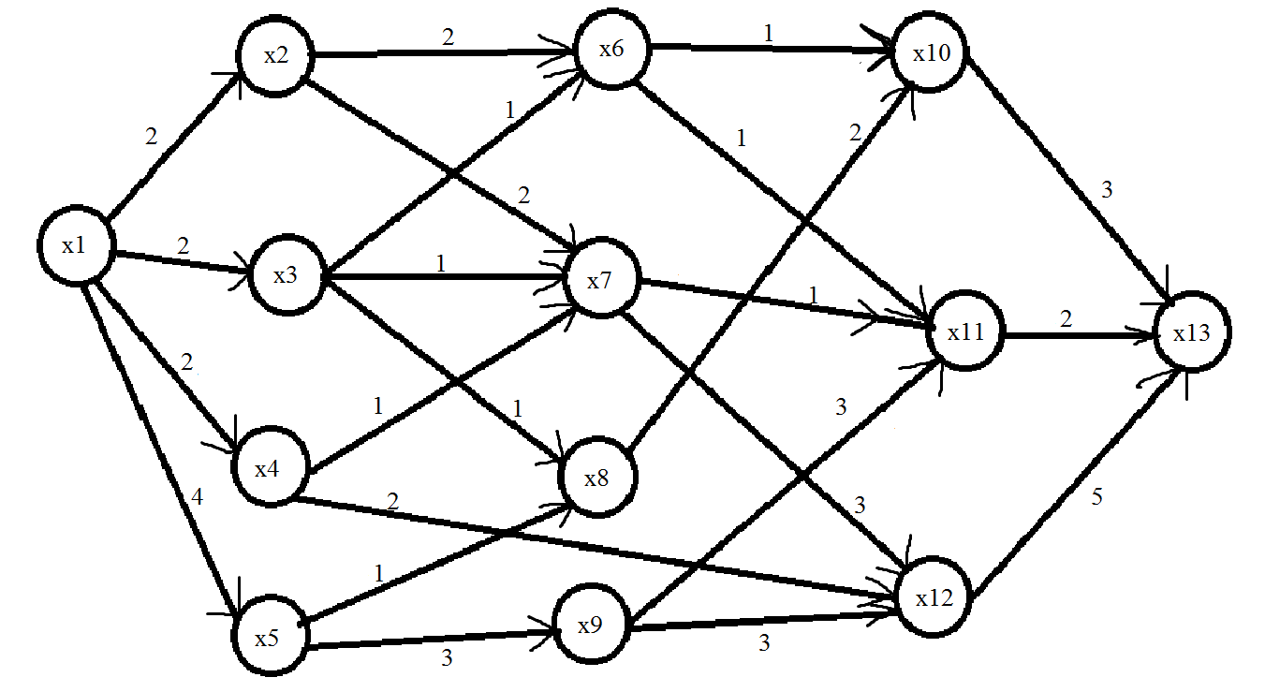

Распределим дуги по множествам

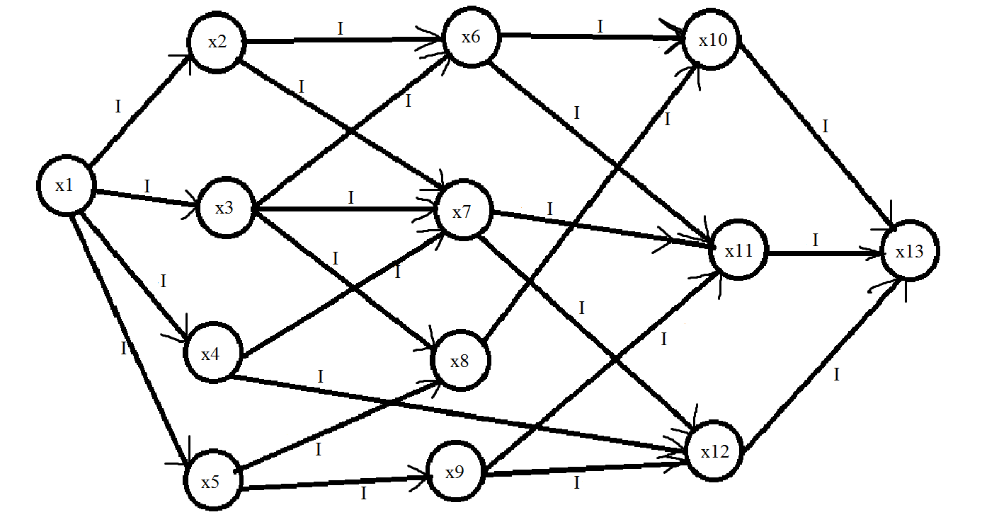

Возьмем увеличивающий путь

(x1, x2) (x2, x6) (x6, x10) (x10, x13)

Найдем величину, на которую можно увеличить поток

min {

i(x1, x2) = c(x1, x2) - f(x1, x2) = 2 - 0 = 2

i(x2, x6) = c(x2, x6) - f(x2, x6) = 2 - 0 = 2

i(x6, x10) = c(x6, x10) - f(x6, x10) = 1 - 0 = 1

i(x10, x13) = c(x10, x13) - f(x10, x13) = 3 - 0 = 3

} = 1

Увеличим поток на данную величину

f(x1, x2) = 0 + 1 = 1

f(x2, x6) = 0 + 1 = 1

f(x6, x10) = 0 + 1 = 1

f(x10, x13) = 0 + 1 = 1

Распределим дуги по множествам

f(x1, x2) = 1 < c(x1, x2) = 2 => (x1, x2) є IR

f(x2, x6) = 1 < c(x2, x6) = 2 => (x2, x6) є IR

f(x6, x10) = 1 = c(x6, x10) =>(x6, x10) є R

f(x10, x13) = 1 < c(x10, x13) = 3 => (x10, x13) є IR

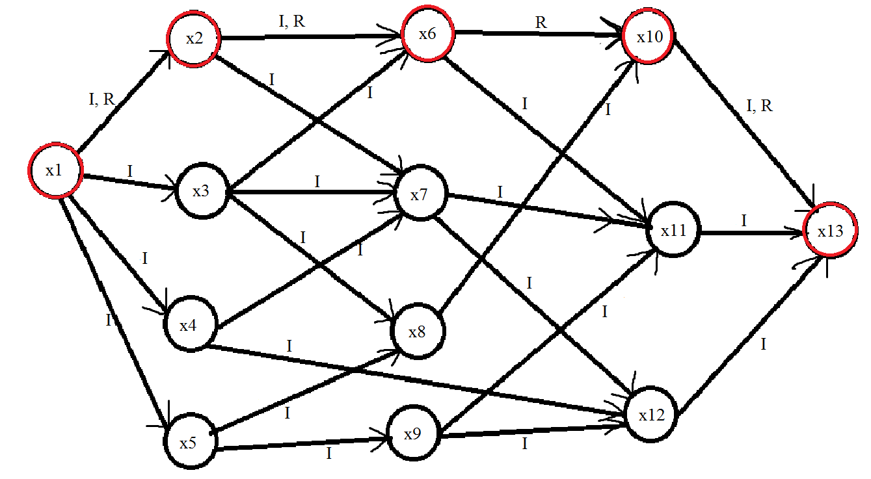

Возьмем увеличивающий путь

(x1, x3) (x3, x8) (x8, x10) (x10, x13)

Найдем величину, на которую можно увеличить поток

min {

i(x1, x3) = c(x1, x3) - f(x1, x3) = 2 - 0 = 2

i(x3, x8) = c(x3, x8) - f(x3, x8) = 1 - 0 = 1

i(x8, x10) = c(x8, x10) - f(x8, x10) = 2 - 0 = 2

i(x10, x13) = c(x10, x13) - f(x10, x13) = 3 - 1 = 2

} = 1

Увеличим поток на данную величину

f(x1, x3) = 0 + 1 = 1

f(x3, x8) = 0 + 1 = 1

f(x8, x10) = 0 + 1 = 1

f(x10, x13) = 1 + 1 = 2

Распределим дуги по множествам

f(x1, x3) = 1 < c(x1, x3) = 2 => (x1, x3) є IR

f(x3, x8) = 1 = c(x3, x8) =>(x3, x8) є R

f(x8, x10) = 1 < c(x8, x10) = 2 => (x8, x10) є IR

f(x10, x13) = 2 < c(x10, x13) = 3 => (x10, x13) є IR

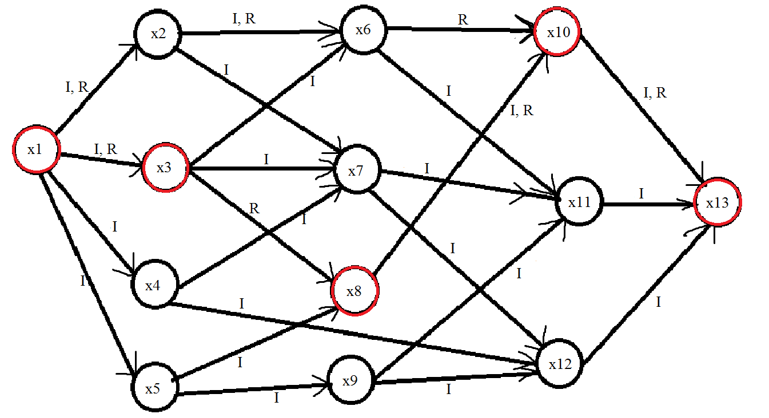

Возьмем увеличивающий путь

(x1, x5) (x5, x8) (x8, x10) (x10, x13)

Найдем величину, на которую можно увеличить поток

min {

i(x1, x5) = c(x1, x5) - f(x1, x5) = 3 - 0 = 3

i(x5, x8) = c(x5, x8) - f(x5, x8) = 1 - 0 = 1

i(x8, x10) = c(x8, x10) - f(x8, x10) = 2 - 1 = 1

i(x10, x13) = c(x10, x13) - f(x10, x13) = 3 - 2 = 1

} = 1

Увеличим поток на данную величину

f(x1, x5) = 0 + 1 = 1

f(x5, x8) = 0 + 1 = 1

f(x8, x10) = 1 + 1 = 2

f(x10, x13) = 2 + 1 = 3

Распределим дуги по множествам

f(x1, x5) = 1 < c(x1, x5) = 3 => (x1, x5) є IR

f(x5, x8) = 1 = c(x5, x8) =>(x5, x8) є R

f(x8, x10) = 2 = c(x8, x10) =>(x8, x10) є R

f(x10, x13) = 3 = c(x10, x13) =>(x10, x13) є R

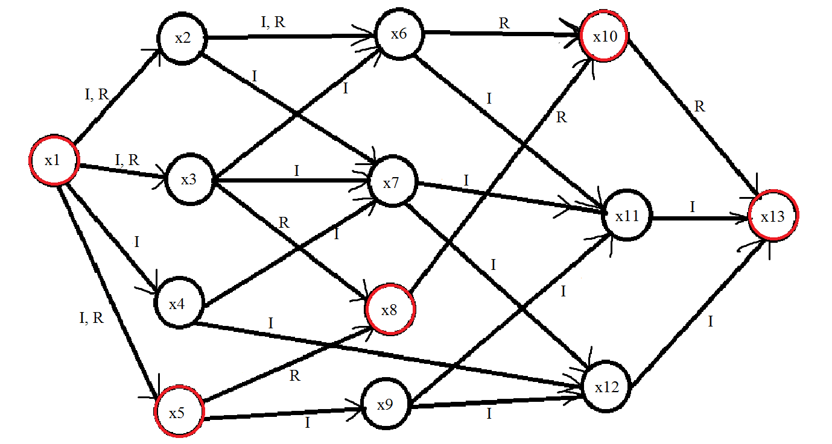

Возьмем увеличивающий путь

(x1, x2) (x2, x6) (x6, x11) (x11, x13)

Найдем величину, на которую можно увеличить поток

min {

i(x1, x2) = c(x1, x2) - f(x1, x2) = 2 - 1 = 1

i(x2, x6) = c(x2, x6) - f(x2, x6) = 2 - 1 = 1

i(x6, x11) = c(x6, x11) - f(x6, x11) = 1 - 0 = 1

i(x11, x13) = c(x11, x13) - f(x11, x13) = 2 - 0 = 2

} = 1

Увеличим поток на данную величину

f(x1, x2) = 1 + 1 = 2

f(x2, x6) = 1 + 1 = 2

f(x6, x11) = 0 + 1 = 1

f(x11, x13) = 0 + 1 = 1

Распределим дуги по множествам

f(x1, x2) = 2 = c(x1, x2) =>(x1, x2) є R

f(x2, x6) = 2 = c(x2, x6) =>(x2, x6) є R

f(x6, x11) = 1 = c(x6, x11) =>(x6, x11) є R

f(x11, x13) = 1 < c(x11, x13) = 2 => (x11, x13) є IR

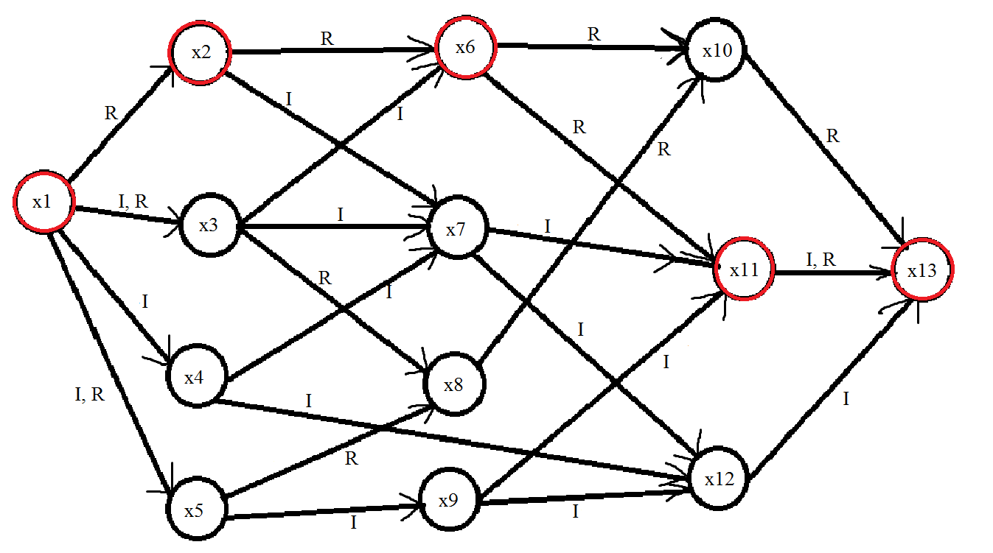

Возьмем увеличивающий путь

(x1, x3) (x3, x7) (x7, x11) (x11, x13)

Найдем величину, на которую можно увеличить поток

min {

i(x1, x3) = c(x1, x3) - f(x1, x3) = 2 - 1 = 1

i(x3, x7) = c(x3, x7) - f(x3, x7) = 1 - 0 = 1

i(x7, x11) = c(x7, x11) - f(x7, x11) = 1 - 0 = 1

i(x11, x13) = c(x11, x13) - f(x11, x13) = 2 - 1 = 1

} = 1

Увеличим поток на данную величину

f(x1, x3) = 1 + 1 = 2

f(x3, x7) = 0 + 1 = 1

f(x7, x11) = 0 + 1 = 1

f(x11, x13) = 1 + 1 = 2

Распределим дуги по множествам

f(x1, x3) = 2 = c(x1, x3) =>(x1, x3) є R

f(x3, x7) = 1 = c(x3, x7) =>(x3, x7) є R

f(x7, x11) = 1 = c(x7, x11) =>(x7, x11) є R

f(x11, x13) = 2 = c(x11, x13) =>(x11, x13) є R

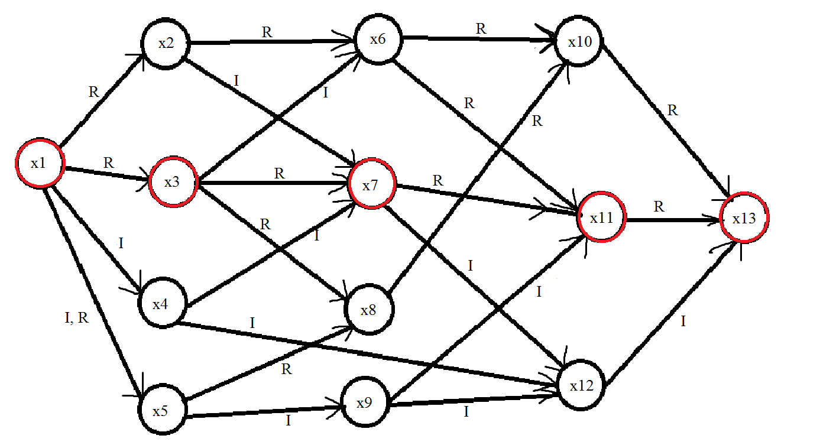

Возьмем увеличивающий путь

(x1, x4) (x4, x12) (x12, x13)

Найдем величину, на которую можно увеличить поток

min {

i(x1, x4) = c(x1, x4) - f(x1, x4) = 2 - 0 = 2

i(x4, x12) = c(x4, x12) - f(x4, x12) = 2 - 0 = 2

i(x12, x13) = c(x12, x13) - f(x12, x13) = 5 - 0 = 5

} = 2

Увеличим поток на данную величину

f(x1, x4) = 0 + 2 = 2

f(x4, x12) = 0 + 2 = 2

f(x12, x13) = 0 + 2 = 2

Распределим дуги по множествам

f(x1, x4) = 2 = c(x1, x4) =>(x1, x4) є R

f(x4, x12) = 2 = c(x4, x12) =>(x4, x12) є R

f(x12, x13) = 2 < c(x12, x13) = 5 => (x12, x13) є IR

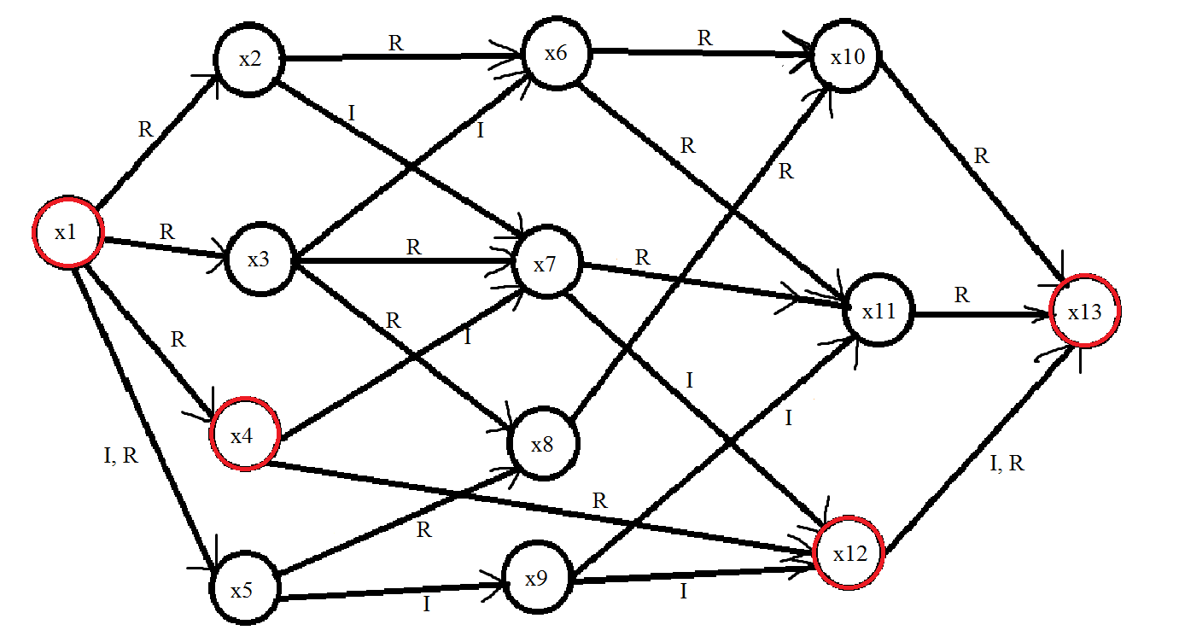

Возьмем увеличивающий путь

(x1, x5) (x5, x9) (x9, x12) (x12, x13)

Найдем величину, на которую можно увеличить поток

min {

i(x1, x5) = c(x1, x5) - f(x1, x5) = 3 - 1 = 2

i(x5, x9) = c(x5, x9) - f(x5, x9) = 3 - 0 = 3

i(x9, x12) = c(x9, x12) - f(x9, x12) = 3 - 0 = 3

i(x12, x13) = c(x12, x13) - f(x12, x13) = 5 - 2 = 3

} = 2

Увеличим поток на данную величину

f(x1, x5) = 1 + 2 = 3

f(x5, x9) = 0 + 2 = 2

f(x9, x12) = 0 + 2 = 2

f(x12, x13) = 2 + 2 = 4

Распределим дуги по множествам

f(x1, x5) = 3 = c(x1, x5) =>(x1, x5) є R

f(x5, x9) = 2 < c(x5, x9) = 3 => (x5, x9) є IR

f(x9, x12) = 2 < c(x9, x12) = 3 => (x9, x12) є IR

f(x12, x13) = 4 < c(x12, x13) = 5 => (x12, x13) є IR

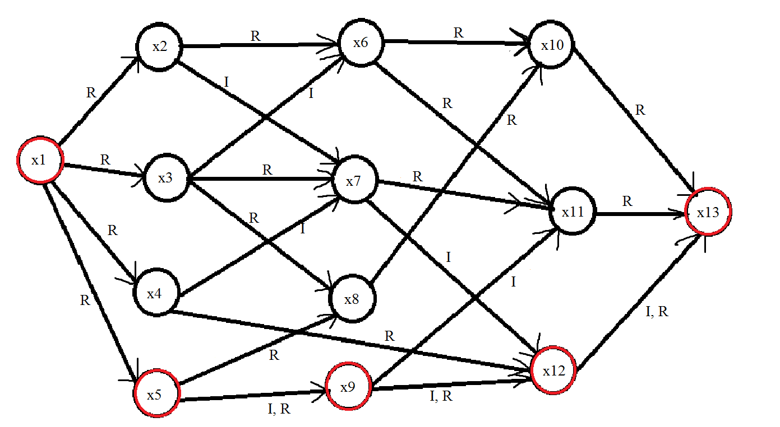

Увеличивающего пути больше нет, следовательно, закончить алгоритм

Пройденные пути

(x1, x2)(x2, x6)(x6, x10)(x10, x13)

(x1, x3)(x3, x8)(x8, x10)(x10, x13)

(x1, x5)(x5, x8)(x8, x10)(x10, x13)

(x1, x2)(x2, x6)(x6, x11)(x11, x13)

(x1, x3)(x3, x7)(x7, x11)(x11, x13)

(x1, x4)(x4, x12)(x12, x13)

(x1, x5)(x5, x9)(x9, x12)(x12, x13)

Максимальное увеличение потока равно 9

Код программы, которая вычисляет максимальное увеличение потока

#include<iostream>

#include<string>

#include<vector>

#include<algorithm>

using namespace std;

class Edge

{

private:

int x;

int y;

string multi;

int c = 0;

int f = 0;

bool color = false;

public:

Edge() {}

Edge(int i, int j) :x(i), y(j) {}

Edge(int i, int j, int c) :x(i), y(j), c(c) {}

void set_multi(string m)

{

this->multi = m;

}

string get_multi()

{

return multi;

}

void set_tops(int x, int y)

{

this->x = x;

this->y = y;

}

int begin() { return x; }

int end() { return y; }

friend ostream& operator<<(ostream&os, Edge&e)

{

os << "(x" << e.x << ", x" << e.y << ")";

return os;

}

bool operator==(Edge e)

{

if (this->x == e.x && this->y == e.y)

{

return true;

}

else

{

return false;

}

}

bool operator<(Edge e)

{

return this->c-f < e.c-e.f;

}

int& get_f() { return f; }

int get_c() { return c; }

void set_c(int f) { this->c = c; }

bool get_color() { return color; }

void set_color(bool val) { color = val; }

int r() { return c - f; }

};

class Graf

{

private:

vector<Edge>edges;

bool way(Graf& g, vector<Edge>&res, int x, int y)

{

if (x == y) { return true; }

vector<Edge>temp = g.get_parents(y);

int size = temp.size();

bool check = false;

for (int i = 0; i < size; i++)

{

if ((temp[i].get_multi() == "I" || temp[i].get_multi() == "IR"))

{

if (!temp[i].get_color())

{

if (way(g, res, x, temp[i].begin()))

{

temp[i].set_color(true);

res.push_back(temp[i]);

check = true;

}

}

}

if (check) { return true; }

}

return false;

}

void set_multi(Graf& g)

{

cout << "Распределим дуги по множествам" << endl;

for_each(g.edges.begin(), g.edges.end(), [](Edge&j)

{

if (j.get_f() == 0)

{

cout << "f" << j << " = 0 => " << j << " є I" << endl;

j.set_multi("I");

}

else if (j.get_f() > 0 && j.get_f() != j.get_c())

{

cout << "f" << j << " = "<<j.get_f()<<" < c" << j <<" = "<<j.get_c()<<" => " <<j <<" є IR" << endl;

j.set_multi("IR");

}

else

{

cout << "f" << j << " = " << j.get_f() << " = c" << j << " =>" << j << " є R" << endl;

j.set_multi("R");

}

});

}

void change_multi(Graf &g,vector<Edge>way)

{

cout << "Распределим дуги по множествам" << endl;

for_each(way.begin(), way.end(), [&](Edge j)

{

if (g.find_edge(j).get_f() == 0)

{

cout << "f" << g.find_edge(j) << " = 0 => " << g.find_edge(j) << " є I" << endl;

g.find_edge(j).set_multi("I");

}

else if (g.find_edge(j).get_f() > 0 && g.find_edge(j).get_f() != g.find_edge(j).get_c())

{

cout << "f" << g.find_edge(j) << " = " << g.find_edge(j).get_f() << " < c" << g.find_edge(j) << " = " << g.find_edge(j).get_c() << " => " << g.find_edge(j) << " є IR" << endl;

g.find_edge(j).set_multi("IR");

}

else

{

cout << "f" << g.find_edge(j) << " = " << g.find_edge(j).get_f() << " = c" << g.find_edge(j) << " =>" << g.find_edge(j) << " є R" << endl;

g.find_edge(j).set_multi("R");

}

});

}

void inc_f(Graf& g, vector<Edge>way, int val)

{

cout << "Увеличим поток на данную величину" << endl;

Edge temp;

int size = way.size();

for (int i = 0; i < size; i++)

{

temp = *find(g.edges.begin(), g.edges.end(), way[i]);

cout << "f" << temp << " = " << temp.get_f() << " + " << val << " = " << temp.get_f() + val << endl;

find(g.edges.begin(), g.edges.end(), way[i])->get_f() += val;

}

}

void reset()

{

for_each(edges.begin(), edges.end(), [](Edge &i)

{

i.set_color(false);

});

}

public:

Graf(){}

int size() { return edges.size(); }

void set_edge(int x, int y)

{

if (!(find(edges.begin(), edges.end(), Edge(x, y)) != edges.end()))

{

edges.push_back(Edge(x, y));

}

}

void set_edge(int x, int y, int c)

{

if (!(find(edges.begin(), edges.end(), Edge(x, y)) != edges.end()))

{

edges.push_back(Edge(x, y, c));

}

}

vector<Edge> get_childs(int x)

{

vector<Edge> res;

for (int i = 0; i < edges.size(); i++)

{

if (edges[i].begin() == x)

{

res.push_back(edges[i]);

}

}

return res;

}

vector<Edge> get_parents(int x)

{

vector<Edge> res;

for (int i = 0; i < edges.size(); i++)

{

if (edges[i].end() == x)

{

res.push_back(edges[i]);

}

}

return res;

}

vector<Edge> find_way(int x, int y)

{

vector<Edge>res;

way(*this, res, x, y);

return res;

}

Edge& get_edge(int x, int y)

{

return *find(edges.begin(), edges.end(), Edge(x, y));

}

Edge& find_edge(Edge search)

{

return *find(edges.begin(), edges.end(), search);

}

int max_f(int x, int y)

{

bool flag = true;

vector<Edge>res;

vector<vector<Edge>>ways;

int result = 0;

set_multi(*this);

while (flag)

{

if (!(way(*this, res, x, y)))

{

flag = false;

cout << "Увеличивающего пути больше нет, следовательно закончить алгоритм"<< endl;

cout << "Пройденные пути" << endl;

for_each(ways.begin(), ways.end(), [](vector<Edge>i)

{

for_each(i.begin(), i.end(), [](Edge j)

{

cout << j;

});

cout << endl;

});

return result;

}

this->reset();

cout << "Возьмем увеличивающий путь" << endl;

for (Edge i : res)

{

cout << i << " ";

}

cout << endl;

cout << "Найдем величину на которую можно увеличить поток" << endl;

int min = min_element(res.begin(), res.end())->r();

cout << "min {" << endl;

for (Edge i : res)

{

cout << "i" << i << " = c" << i << " - f" << i << " = " << i.get_c()<<" - "<<i.get_f() <<" = "<<i.r()<< endl;

}

cout << "} = " << min << endl;

result += min;

inc_f(*this, res, min);

change_multi(*this, res);

vector<Edge>parent = this->get_parents(y);

for (Edge&i : parent)

{

if (i.get_multi() != "R")

{

flag = true;

break;

}

else

{

flag = false;

}

}

ways.push_back(res);

res.clear();

}

cout << "Разрез при конечной вершине насыщеный, следовательно закончить алгоритм" << endl;

cout << "Пройденные пути" << endl;

for_each(ways.begin(), ways.end(), [](vector<Edge>i)

{

for_each(i.begin(), i.end(), [](Edge j)

{

cout << j;

});

cout << endl;

});

return result;

}

};

int main()

{

setlocale(0, "Russian");

Graf g;

g.set_edge(1, 2, 2);

g.set_edge(1, 3, 2);

g.set_edge(1, 4, 2);

g.set_edge(1, 5, 3);

g.set_edge(2, 6, 2);

g.set_edge(2, 7, 2);

g.set_edge(3, 6, 1);

g.set_edge(3, 7, 1);

g.set_edge(3, 8, 1);

g.set_edge(4, 7, 1);

g.set_edge(4, 12, 2);

g.set_edge(5, 8, 1);

g.set_edge(5, 9, 3);

g.set_edge(6, 10, 1);

g.set_edge(6, 11, 1);

g.set_edge(7, 11, 1);

g.set_edge(7, 12, 3);

g.set_edge(8, 10, 2);

g.set_edge(9, 11, 3);

g.set_edge(9, 12, 3);

g.set_edge(10, 13, 3);

g.set_edge(11, 13, 2);

g.set_edge(12, 13, 5);

cout << "Максимальное увеличение потока от вершины?" << endl;

int x1;

cin >> x1;

cout << "До вершины?" << endl;

int x2;

cin >> x2;

int max = g.max_f(x1, x2);

cout << "Максимальное увеличение потока равно" << endl;

cout << max << endl;

system("pause");

return 0;

}

**Максимальный поток минимальной стоимости**

Число вне скобок – стоимость за единицу потока. Число внутри скобок – пропускная способность

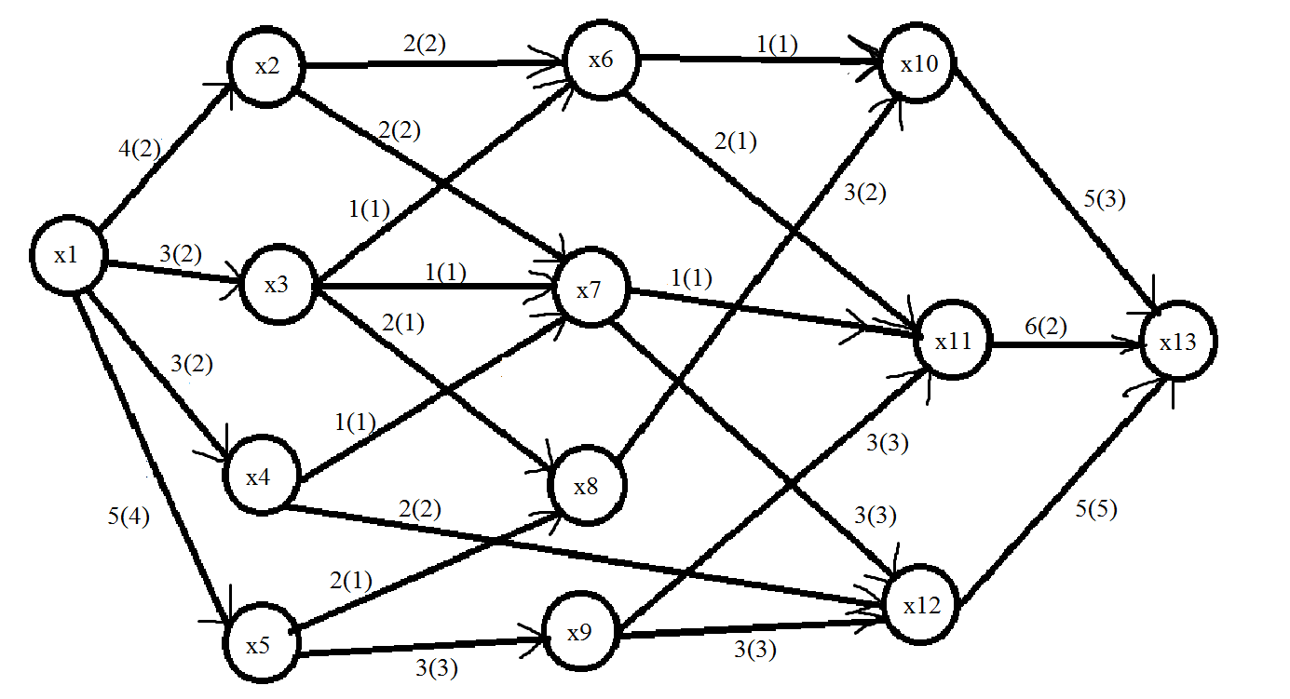

Распределим дуги по множествам

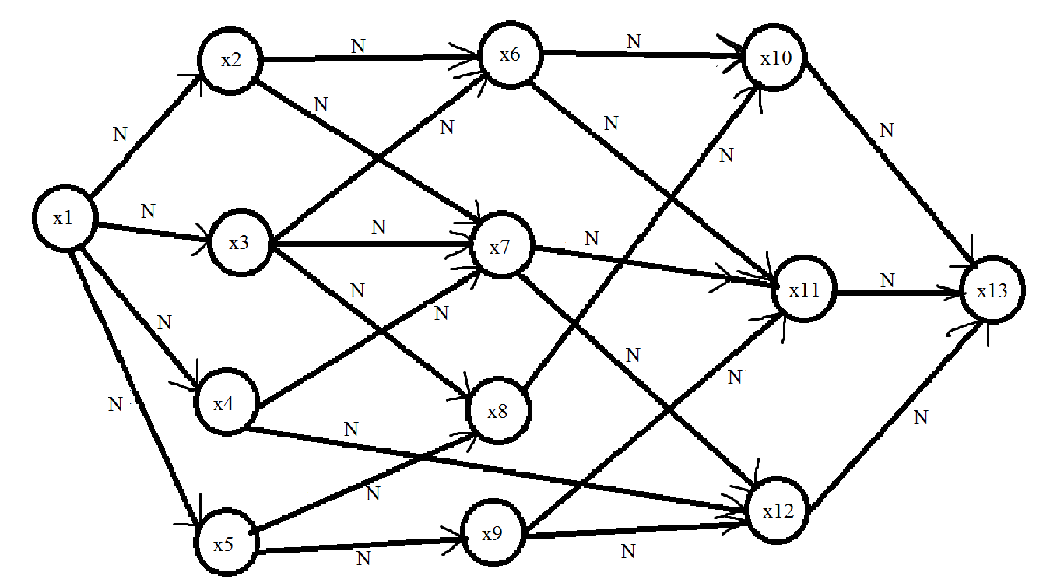

Окрасим вершину x1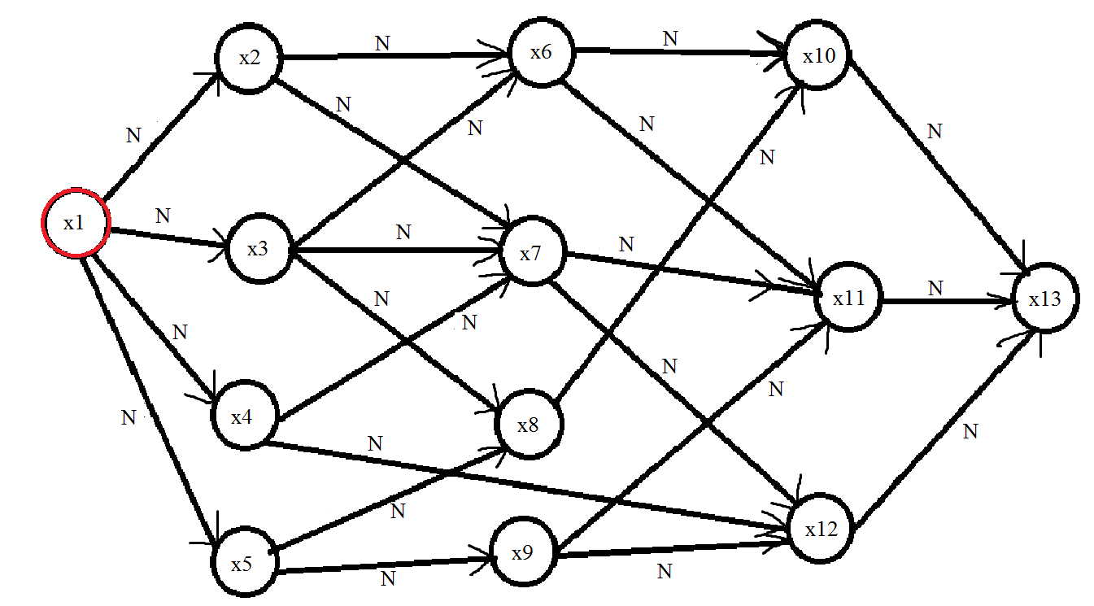

Так как увеличивающего потока нет, то увеличим вершинные числа не окрашенных вершин

P(xi)= 1, i =

Распределим дуги по множествам

P(x2) – P(x1) = 1 != a(x1, x2) = 4 => (x1, x2) є N

P(x3) – P(x1) = 1 != a(x1, x3) = 3 => (x1, x3) є N

P(x4) – P(x1) = 1 != a(x1, x4) = 3 => (x1, x4) є N

P(x5) – P(x1) = 1 != a(x1, x5) = 5 => (x1, x5) є N

Окрасим вершину x1



Увеличим вершинные числа не окрашенных вершин

P(xi)= 2, i =

Распределим дуги по множествам

P(x2) – P(x1) = 2 != a(x1, x2) = 4 => (x1, x2) є N

P(x3) – P(x1) = 2 != a(x1, x3) = 3 => (x1, x3) є N

P(x4) – P(x1) = 2 != a(x1, x4) = 3 => (x1, x4) є N

P(x5) – P(x1) = 2 != a(x1, x5) = 5 => (x1, x5) є N

Окрасим вершины x1

Увеличим вершинные числа не окрашенных вершин

P(xi)= 3, i =

Распределим дуги по множествам

P(x2) – P(x1) = 3 != a(x1, x2) = 4 => (x1, x2) є N

P(x3) – P(x1) = 3 = a(x1, x3) = 3 => (x1, x3) є I

P(x4) – P(x1) = 3 = a(x1, x4) = 3 => (x1, x4) є I

P(x5) – P(x1) = 3 != a(x1, x5) = 5 => (x1, x5) є N

Окрасим вершины x1, x3, x4

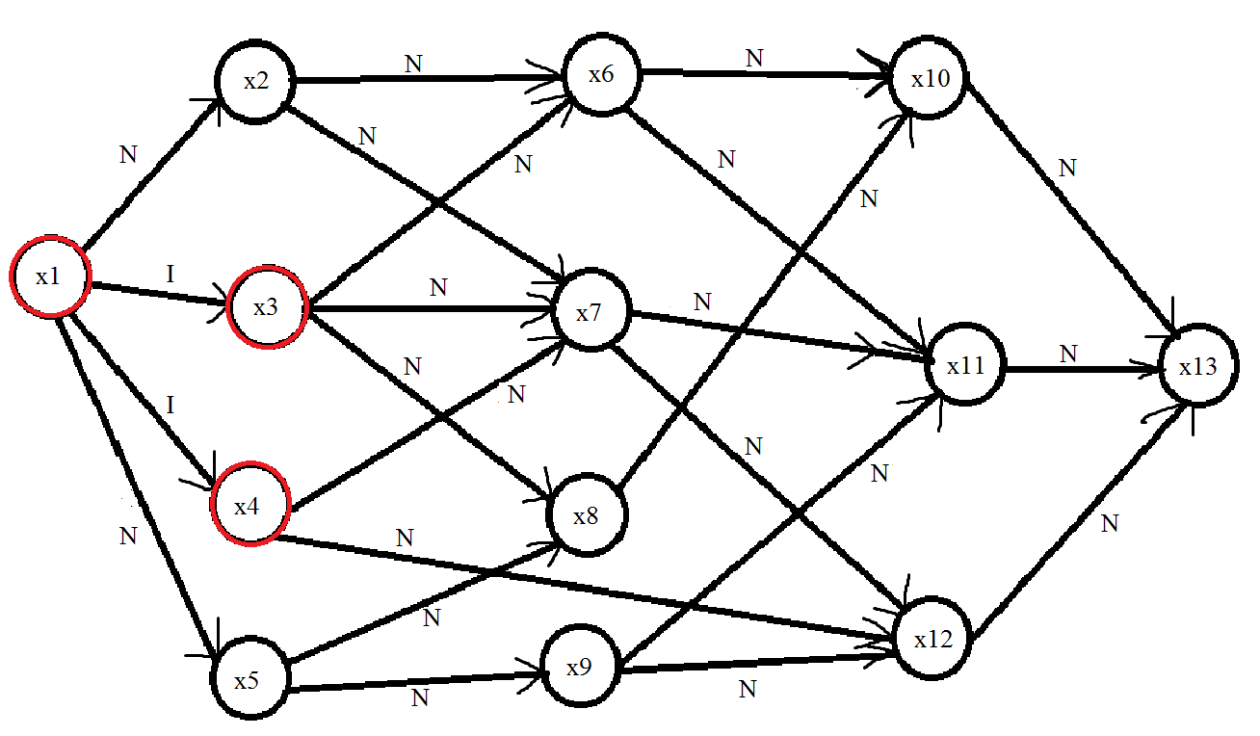

Увеличим вершинные числа не окрашенных вершин

P(x2) = 4, P(xi)= 4, i =

Распределим дуги по множествам

P(x2) – P(x1) = 4 = a(x1, x2) = 4 => (x1, x2) є I

P(x6) – P(x3) = 4 – 3 = 1 = a(x3, x6) = 1 => (x3, x6) є I

P(x7) – P(x3) = 4 – 3 = 1 = a(x3, x7) = 1 => (x3, x7) є I

P(x8) – P(x3) = 4 – 3 = 1 != a(x3, x8) = 2 => (x3, x8) є N

P(x7) – P(x4) = 4 – 3 = 1 = a(x4, x7) = 1 => (x4, x7) є I

P(x12) – P(x4) = 4 – 3 = 1 != a(x4, x7) = 2 => (x4, x7) є N

Окрасим вершины x1, x2, x3, x4, x6, x7

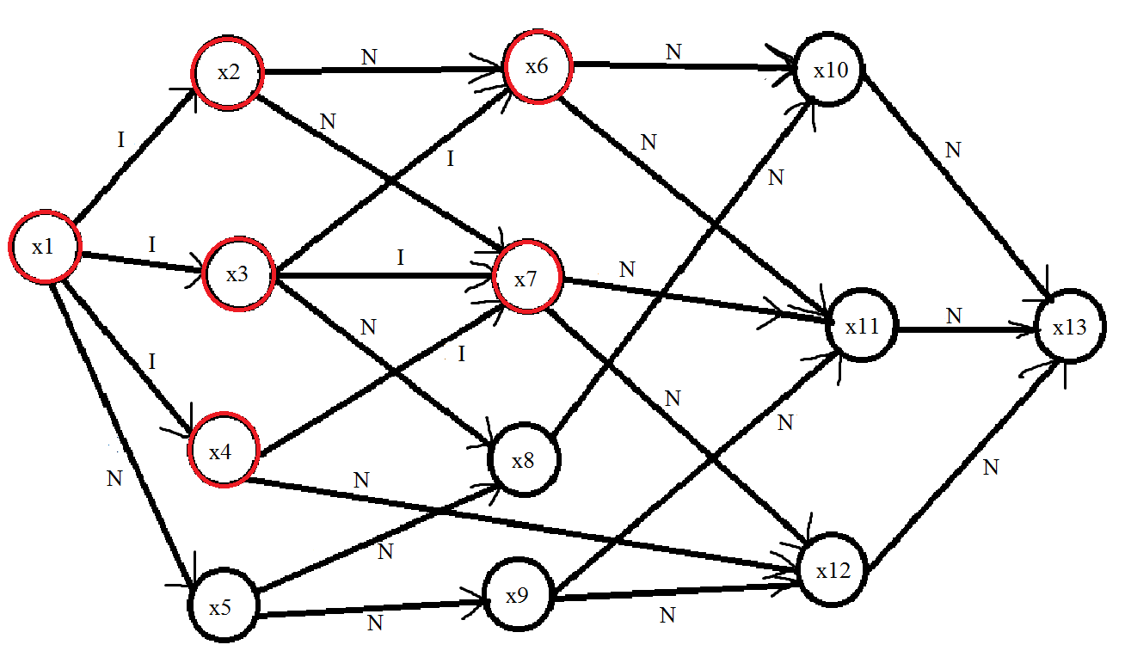

Увеличим вершинные числа не окрашенных вершин

P(x5) = 5, P(x8) = 5, P(x9) = 5, P(x10) = 5, P(x11) = 5, P(x12) = 5, P(x13) = 5

Распределим дуги по множествам

P (x5) – P(x1) = 5 = a(x1, x5) = 5 => (x1, x5) є I

P(x10) – P(x6) = 5 – 4 = 1 = a(x6, x10) = 1 => (x6, x10) є I

P(x11) – P(x6) = 5 – 4 = 1 != a(x6, x11) = 2 => (x6, x11) є N

P(x11) – P(x7) = 5 – 4 = 1 = a(x7, x11) = 1 => (x7, x11) є I

P(x12) – P(x7) = 5 – 4 = 1 != a(x7, x12) = 3 => (x7, x12) є N

P(x8) – P(x3) = 5 – 3 = 2 = a(x3, x8) = 2 => (x3, x8) є I

P(x12) – P(x4) = 5 – 3 = 2 = a(x4, x12) = 2 => (x4, x12) є I

Окрасим вершины x1, x2, x3, x4, x5, x6, x7, x8, x10, x11, x12

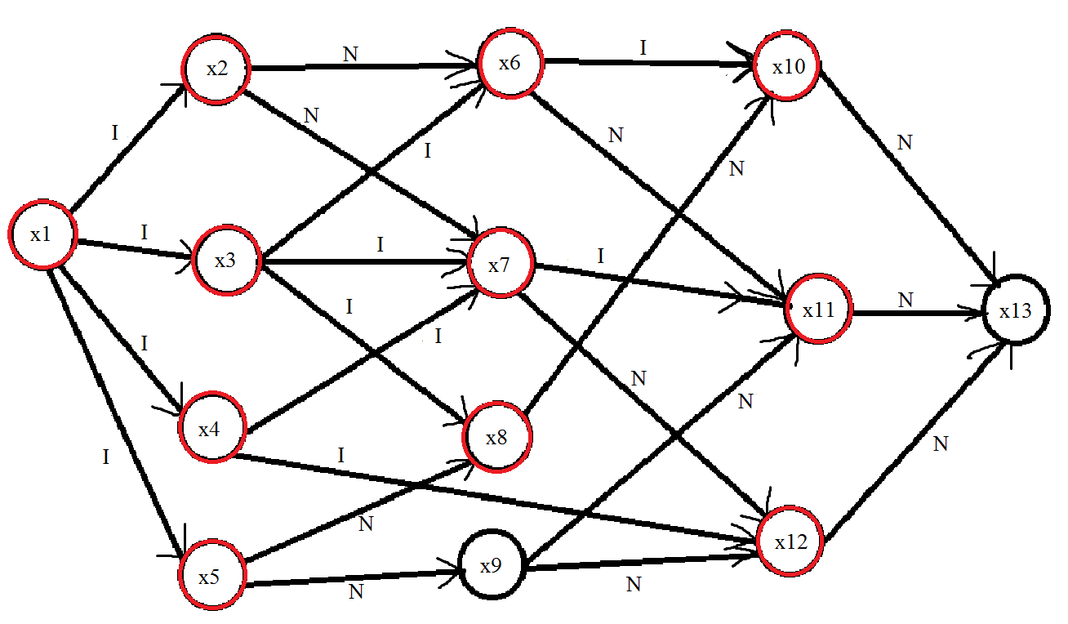

Увеличим вершинные числа не окрашенных вершин

P(x9) = 6, P(x13) = 6

Распределим дуги по множествам

P (x9) – P(x5) = 6 – 5 = 1 != a(x5, x9) = 3 => (x5, x9) є N

P(x13) – P(x10) = 6 – 5 = 1 != a(x10, x13) = 5 => (x10, x13) є N

P(x13) – P(x11) = 6 – 5 = 1 != a(x11, x13) = 6 => (x11, x13) є N

P(x13) – P(x12) = 6 – 5 = 1 != a(x12, x13) = 5 => (x12, x13) є N

Увеличим вершинные числа не окрашенных вершин

P(x9) = 7, P(x13) = 7

Распределим дуги по множествам

P (x9) – P(x5) = 7 – 5 = 2 != a(x5, x9) = 3 => (x5, x9) є N

P(x13) – P(x10) = 7 – 5 = 2 != a(x10, x13) = 5 => (x10, x13) є N

P(x13) – P(x11) = 7 – 5 = 2 != a(x11, x13) = 6 => (x11, x13) є N

P(x13) – P(x12) = 7 – 5 = 2 != a(x12, x13) = 5 => (x12, x13) є N

Увеличим вершинные числа не окрашенных вершин

P(x9) = 8, P(x13) = 8

Распределим дуги по множествам

P (x9) – P(x5) = 8 – 5 = 3 = a(x5, x9) = 3 => (x5, x9) є I

P(x13) – P(x10) = 8 – 5 = 3 != a(x10, x13) = 5 => (x10, x13) є N

P(x13) – P(x11) = 8 – 5 = 3 != a(x11, x13) = 6 => (x11, x13) є N

P(x13) – P(x12) = 8 – 5 = 3 != a(x12, x13) = 5 => (x12, x13) є N

Окрасим вершины x1, x2, x3, x4, x5, x6, x7, x8, x9, x10, x11, x12

Увеличим вершинные числа не окрашенных вершин

P(x13) = 9

Распределим дуги по множествам

P(x13) – P(x10) = 9 – 5 = 4 != a(x10, x13) = 5 => (x10, x13) є N

P(x13) – P(x11) = 9 – 5 = 4 != a(x11, x13) = 6 => (x11, x13) є N

P(x13) – P(x12) = 9 – 5 = 4 != a(x12, x13) = 5 => (x12, x13) є N

Увеличим вершинные числа не окрашенных вершин

P(x13) = 10

Распределим дуги по множествам

P(x13) – P(x10) = 10 – 5 = 5 = a(x10, x13) = 5 => (x10, x13) є I

P(x13) – P(x11) = 10 – 5 = 5 != a(x11, x13) = 6 => (x11, x13) є N

P(x13) – P(x12) = 10 – 5 = 5 = a(x12, x13) = 5 => (x12, x13) є I

Окрасим вершины x1, x2, x3, x4, x5, x6, x7, x8, x9, x10, x11, x12, x13

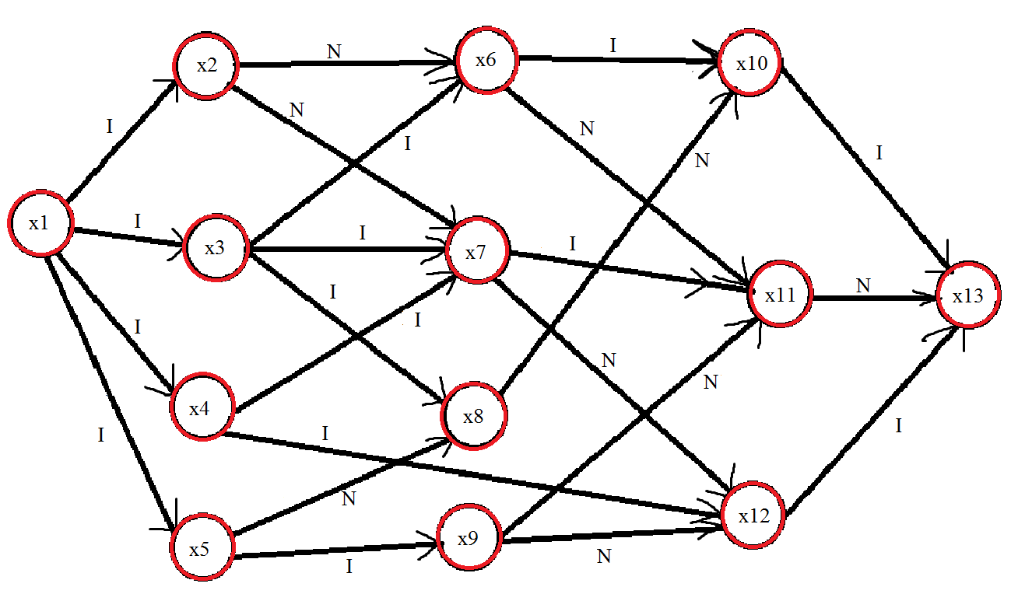

Возьмем увеличивающие пути

1. (x1, x3)(x3, x6)(x6, x10)(x10, x13)
2. (x1, x4)(x4, x12)(x12, x13)

Найдем величину, на которую можно увеличить поток, в каждом из путей.

1. min {i(x1, x3); i(x3, x6); i(x6, x10); i(x10, x13)} = min { 2, 1, 1, 3 } = 1

f(x1, x3) = 1

f(x3, x6) = 1

f(x6, x10) = 1

f(x10, x13) = 1

i(x1, x3) = 2 – 1 = 1

i(x3, x6) = 1 – 1 = 0

i(x6, x10) = 1 – 1 = 0

i(x10, x13) = 3 – 1 = 2

1. min { i(x1, x4); i(x4, x12); i(x12, x13) } = min { 2, 2, 5 } = 2

f(x1, x4) = 2

f(x4, x12) = 2

f(x12, x13) = 2

i(x1, x4) = 2 – 2 = 0

i(x4, x12) = 2 – 2 = 0

i(x12, x13) = 5 – 2 = 3

P(x1) = 0, P(x2) = 4, P(x3) = 3, P(x4) = 3, P(x5) = 5, P(x6) = 4, P(x7) = 4,

P(x8) = 5, P(x9) = 9, P(x10) = 5, P(x11) = 5, P(x12) = 5, P(x13) = 10

Находим увеличивающий путь

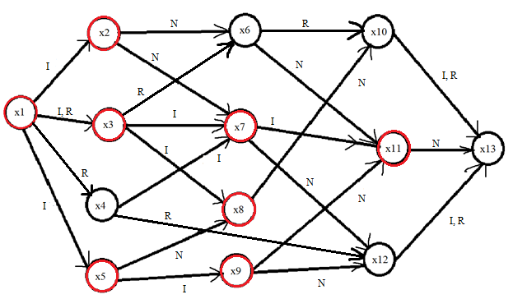

Так как путь найти не удалось, то увеличим вершинные числа не окрашенных вершин

P(x1) = 0, P(x2) = 4, P(x3) = 3, P(x4) = 4, P(x5) = 5, P(x6) = 5, P(x7) = 4,

P(x8) = 5, P(x9) = 9, P(x10) = 6, P(x11) = 5, P(x12) = 6, P(x13) = 11

P(x6) – P(x2) = 5 – 4 = 1 != a(x2, x6) = 2 => (x2, x6) є N

P(x10) – P(x8) = 6 – 5 = 1 != a(x8, x10) = 3 => (x8, x10) є N

P(x12) – P(x9) = 6 – 9 = -3 != a(x12, x9) = 2 => (x12, x9) є N

P(x13) – P(x11) = 11 – 5 = 6 = a(x11, x13) = 6 => (x11, x13) є I

Находим увеличивающий путь

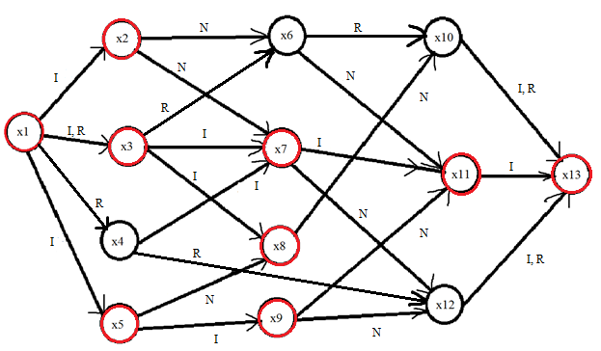

Увеличивающий путь: (x1, x3)(x3, x7)(x7, x11)(x11, x13)

Найдем величину на которую можно увеличить поток

min {i(x1,x3); i(x3, x7); i(x7, x11); i(x11, x13)} = min { 1, 1, 1, 2 } = 1

Увеличим поток на эту величину

f(x1, x3) = 1 + 1 = 2

f(x3, x7) = 1 + 0 = 1

f(x7, x11) = 1 + 0 = 1

f(x11, x13) = 1 + 0 = 1

i(x1, x3) = 1 – 1 = 0

i(x3, x7) = 1 – 1 = 0

i(x7, x11) = 1 – 1 = 0

i(x11, x13) = 2 – 1 = 1

(x1, x3) є I, R

(x3, x7) є R

(x7, x11) є R

(x11, x13) є I, R

P(x1) = 0, P(x2) = 4, P(x3) = 3, P(x4) = 4, P(x5) = 5, P(x6) = 5, P(x7) = 4,

P(x8) = 5, P(x9) = 9, P(x10) = 6, P(x11) = 5, P(x12) = 6, P(x13) = 11

Находим увеличивающий путь

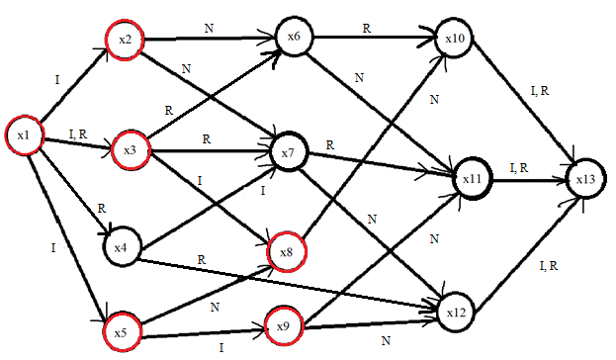

Увеличивающего пути нет, значит увеличим вершинные числа не окрашенных вершин

P(x1) = 0, P(x2) = 4, P(x3) = 3, P(x4) = 5, P(x5) = 5, P(x6) = 6, P(x7) = 5,

P(x8) = 5, P(x9) = 9, P(x10) = 7, P(x11) = 6, P(x12) = 7, P(x13) = 12

P(x6) – P(x2) = 6 – 4 = 2 = a(x2, x6) = 2 => (x2, x6) є I

P(x7) – P(x2) = 5 – 4 = 2 = a(x2, x7) = 2 => (x2, x7) є I

P(x10) – P(x8) = 7 – 5 = 2 != a(x8, x10) = 3 => (x8, x10) є N

P(x12) – P(x9) = 7 – 9 = -2 != a(x12, x9) = 2 => (x12, x9) є N

P(x11) – P(x9) = 6 – 9 = -3 != a(x11, x9) = 3 => (x11, x9) є N

P(x13) – P(x11) = 12 – 6 = 6 = a(x11, x13) = 6, f(x11, x13) = 1 < c(x11, x13) = 2 => (x11, x13) є I, R

Находим увеличивающий путь

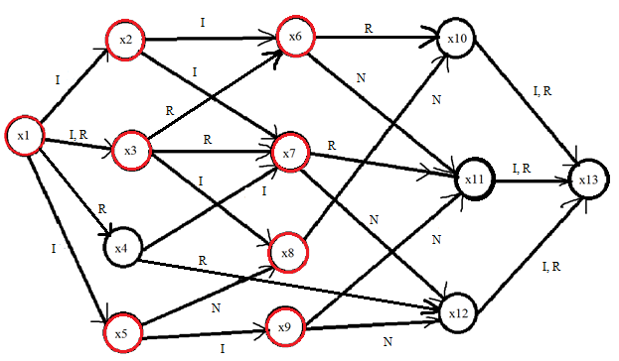

Увеличивающего пути нет, значит увеличим вершинные числа у неокрашенных вершин

P(x1) = 0, P(x2) = 4, P(x3) = 3, P(x4) = 6, P(x5) = 5, P(x6) = 6, P(x7) = 5,

P(x8) = 5, P(x9) = 9, P(x10) = 8, P(x11) = 7, P(x12) = 8, P(x13) = 13

P(x10) – P(x8) = 8 – 5 = 3 = a(x8, x10) = 3 => (x8, x10) є I

P(x12) – P(x9) = 8 – 9 = -1 != a(x12, x9) = 2 => (x12, x9) є N

P(x11) – P(x9) = 7 – 9 = -2 != a(x11, x9) = 3 => (x11, x9) є N

P(x12) – P(x7) = 8 – 5 = 3 = a(x7, x12) = 3 => (x7, x12) є I

Находим увеличивающий путь

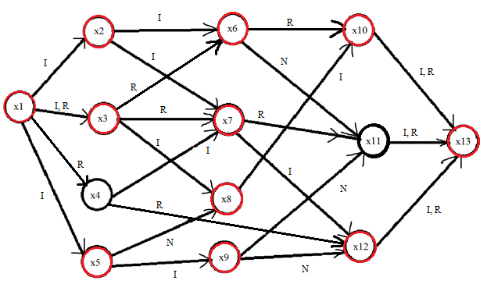

Возьмем увеличивающие пути

1. (x1, x2)(x2, x7)(x7, x12)(x12, x13)
2. (x1, x3)(x3, x8)(x8, x10)(x10, x13)

Найдем величину на которую можно увеличить поток, в каждом из путей

1. min {i(x1, x2); i(x2, x7); i(x7, x12); i(x12, x13)} = { 2, 2, 3, 3 } = 2

f(x1, x2) = 2 + 0 = 2

f(x2, x7) = 2 + 0 = 2

f(x7, x12) = 2 + 0 = 2

f(x12, x13) = 2 + 2 = 4

i(x1, x2) = 2 – 2 = 0

i(x2, x7) = 2 – 2 = 0

i(x7, x12) = 3 – 2 = 1

i(x12, x13) = 3 – 2 = 1

(x1, x2) є R

(x2, x7) є R

(x7, x12) є I, R

(x12, x13) є I, R

1. min{i(x1, x3); i(x3, x8); i(x8, x10); i(x10, x13)} = { 1, 1, 2, 2} = 1

f(x1, x3) = 1 + 1 = 2

f(x3, x8) = 1 + 0 = 1

f(x8, x10) = 1 + 0 = 1

f(x10, x13) = 1 + 1 = 2

i(x1, x3) = 2 – 2 = 0

i(x3, x8) = 1 – 1 = 0

i(x8, x10) = 2 – 1 = 1

i(x10, x13) = 2 – 1 = 1

(x1, x3) є R

(x3, x8) є R

(x8, x10) є I, R

(x10, x13) є I, R

Находим увеличивающий путь

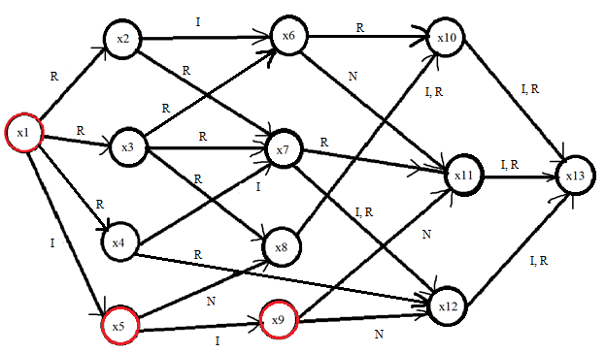

Найти путь не удалось, значит увеличим вершинные числа не окрашеных вершин

P(x1) = 0, P(x2) = 5, P(x3) = 4, P(x4) = 7, P(x5) = 5, P(x6) = 7, P(x7) = 8,

P(x8) = 6, P(x9) = 9, P(x10) = 9, P(x11) = 8, P(x12) = 9, P(x13) = 14

P(x8) – P(x5) = 6 – 5 = 1 != a(x5, x8) = 2 => (x5, x8) є N

P(x11) – P(x9) = 8 – 9 = -1 != a(x11, x9) = 3 => (x11, x9) є N

P(x12) – P(x9) = 9 – 9 = 0 != a(x12, x9) = 2 => (x12, x9) є N

Найти путь не удалось, значит увеличим вершинные числа не окрашенных вершин

P(x1) = 0, P(x2) = 6, P(x3) = 5, P(x4) = 8, P(x5) = 5, P(x6) = 8, P(x7) = 9,

P(x8) = 7, P(x9) = 9, P(x10) = 10, P(x11) = 9, P(x12) = 10, P(x13) = 15

P(x8) – P(x5) = 7 – 5 = 2 = a(x5, x8) = 2 => (x5, x8) є I

P(x11) – P(x9) = 9 – 9 = 0 != a(x11, x9) = 3 => (x11, x9) є N

P(x12) – P(x9) = 10 – 9 = 1 != a(x12, x9) = 2 => (x12, x9) є N

Находим увеличиващий путь

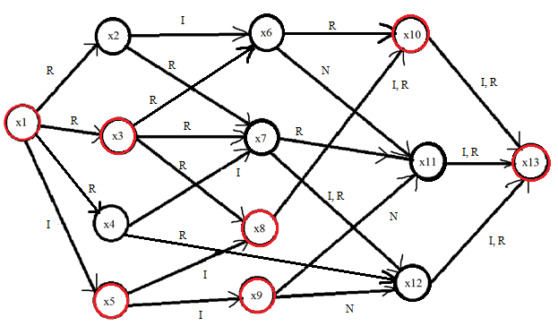

Увеличивающий путь: (x1, x5)(x5, x8)(x8, x10)(x10, x13)

Найдем величину на которую можно увеличить поток

min {i(x1, x5); i(x5, x8); i(x8, x10); i(x10, x13)} = min { 4, 1, 1, 1} = 1

f(x1, x5) = 1 + 0 = 1

f(x5, x8) = 1 + 0 = 1

f(x8, x10) = 1 + 1 = 2

f(x10, x13) = 2 + 1 = 3

i(x1, x5) = 4 – 1 = 3, (x1, x5) є I, R

i(x5, x8) = 1 – 1 = 0, (x5, x8) є R

i(x8, x10) = 2 – 2 = 0, (x8, x10) є R

i(x10, x13) = 1 – 1 = 0, (x10, x13) є R

Находим увеличивающий путь

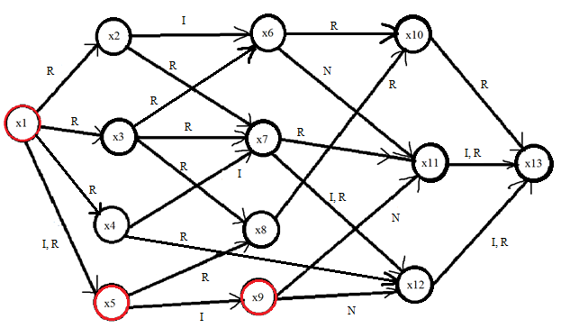

Увеличивающего пути нет, значит увеличим вершинные числа не окрашенных вершин

P(x1) = 0, P(x2) = 7, P(x3) = 6, P(x4) = 9, P(x5) = 5, P(x6) = 9, P(x7) = 10,

P(x8) =8, P(x9) = 9, P(x10) = 11, P(x11) = 10, P(x12) = 11, P(x13) = 16

P(x11) – P(x9) = 10 – 9 = 1 != a(x11, x9) = 3 => (x11, x9) є N

P(x12) – P(x9) = 11 – 9 = 2 = a(x12, x9) = 2 => (x12, x9) є I

Найдем увеличивающий путь

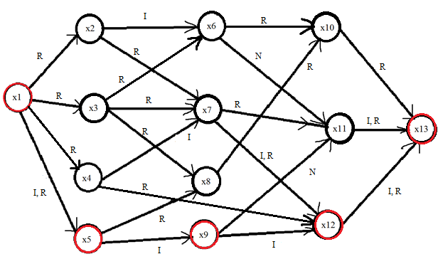

Увеличивающий путь: (x1, x5)(x5, x9)(x9, x12)(x12, x13)

Найдем величину, на которую можно увеличить поток

min{ i(x1, x5); i(x5, x9); i(x9, x12); i(x12, x13)} = min{ 3, 3, 3, 1 } = 1

f(x1, x5) = 1 + 1 = 2

f(x5, x9) = 1 + 0 = 1

f(x9, x12) = 1 + 0 = 1

f(x12, x13) = 4 + 1 = 5

i(x1, x5) = 3 – 2 = 1, (x1, x5) є I, R

i(x5, x9) = 3 – 1 = 2, (x5, x9) є I, R

i(x9, x12) = 3 – 1 = 2, (x9, x12) є I, R

i(x12, x13) = 1 – 1 = 0, (x12, x13) є R

Найдем увеличивающий путь

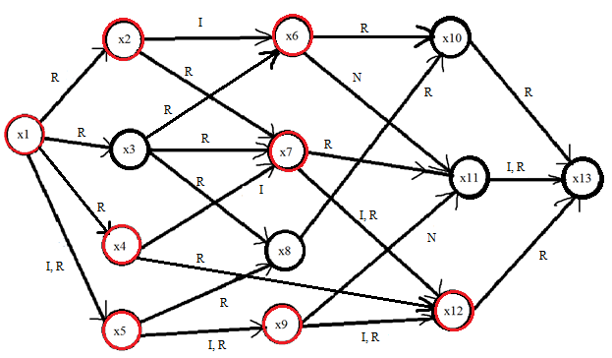

Увеличивающего пути нет, следовательно, увеличим вершинные числа не окрашенных вершин

P(x1) = 0, P(x2) = 7, P(x3) = 7, P(x4) = 9, P(x5) = 5, P(x6) = 9, P(x7) = 10,

P(x8) = 9, P(x9) = 9, P(x10) = 12, P(x11) = 11, P(x12) = 11, P(x13) = 17

P(x11) – P(x9) = 11 – 9 = 2 != a(x11, x9) = 3 => (x11, x9) є N

P(x11) – P(x6) = 11 – 9 = 2 = a(x6, x11) = 2 => (x6, x11) є I

Найдем увеличивающий путь

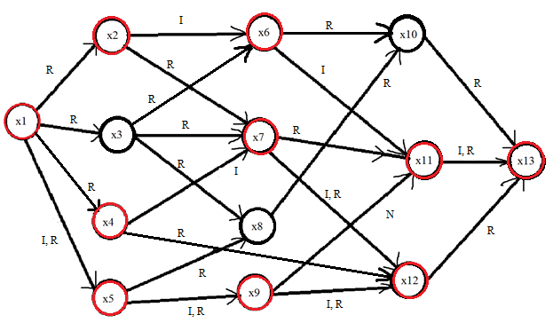

Увеличивающий путь: (x1, x5)(x5, x9)(x9, x12)(x12, x4)(x4, x7)(x7, x2)(x2, x6)(x6, x11)(x11, x13)

min{i(x1, x5); i(x5, x9); i(x9, x12); r(x12, x4); i(x4, x7); r(x7, x2); i(x2, x6); i(x6, x11); i(x11, x13)} = min{1, 2, 2, 1, 2, 2, 1, 1} = 1

f(x1, x5) = 3 + 1 = 4

f(x5, x9) = 1 + 1 = 2

f(x9, x12) = 1 + 1 = 2

f(x12, x4) = 2 – 1 = 1

f(x4, x7) = 1 + 0 = 1

f(x7, x2) = 2 – 1 = 1

f(x2, x6) = 1 + 0 = 1

f(x6, x11) = 1 + 0 = 1

f(x11, x13) = 1 + 1 = 2

i(x1, x5) = 4 – 4 = 0, (x1, x5) є R

i(x5, x9) = 3 – 2 = 1, (x5, x9) є I, R

i(x9, x12) = 3 – 2 = 1, (x9, x12) є I, R

i(x12, x4) = 2 – 1 = 1, (x4, x12) є I, R

i(x4, x7) = 1 – 1 = 0, (x4, x7) є R

i(x7, x2) = 2 – 1 = 1, (x2, x7) є I, R

i(x2, x6) = 2 – 1 = 1, (x2, x6) є I, R

i(x6, x11) = 1 – 1 = 0, (x6, x11) є R

i(x11, x13) = 2 – 2 = 0, (x11, x13) є R

Находим увеличивающий путь

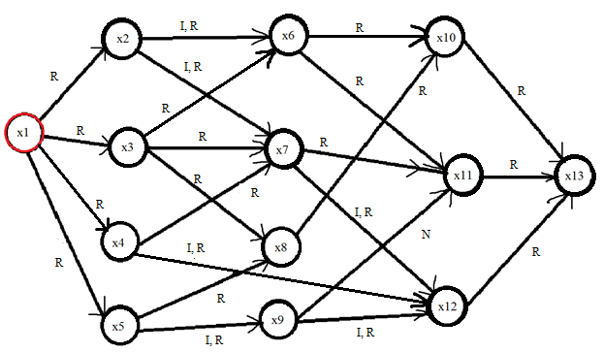

Так как разрез получился насыщенным, то закончим алгоритм

Пройденные пути

1. (x1, x3)(x3, x6)(x6, x10)(x10, x13), f = 1
2. (x1, x4)(x4, x12)(x12, x13), f = 2
3. (x1, x3)(x3, x7)(x7, x11)(x11, x13), f = 1
4. (x1, x3)(x3, x8)(x8, x10)(x10, x13), f = 1
5. (x1, x2)(x2, x7)(x7, x12)(x12, x13), f = 2
6. (x1, x5)(x5, x8)(x8, x10)(x10, x13), f = 1
7. (x1, x5)(x5, x9)(x9, x12)(x12, x13), f = 1
8. (x1, x5)(x5, x9)(x9, x12)(x12, x4)(x4, x7)(x7, x2)(x2, x6)(x6, x11)(x11, x13), f = 1

Суммарное увеличение потока равно 10

Цена переправки 10-ти единиц потока равна

10 + 10*2 + 11 + 13 + 14*2 + 15 + 16 + 26 = 139